

**TEXAS COLLEGE OF MANAGEMENT AND IT**

***Bachelors in Information Technology***

**Project I of JAVA PROGRAMMING**

**Project Title**: **Fun in Programming with JAVA and OOP**

**SUBMITTED BY: SUBMITTED TO:**

Merry Subedi Aasish Gautam and Prakash Koirala Sir

BIT 1st year 2nd SEM Department of Java Progamming

SECTION: “E” Date of Submission: 20th July, 2025

LCID:LC00017003482

**KATHMANDU, 2025**

**Table of Contents**

Contents

**1.** **INTRODUCTION** 3

**2.** **TASK 1: OOP Implementation Task** 4

**3.** **Task 2: Inheritance and Polymorphism Task** 19

**5.** **TASK 3: String and Exception Handling Task** 40

**5.** **TASK 4: Java Collection Tasks** 53

**6.** **TASK 5: Case Study- Design Patterns in Real Project** 68

Case Study: Applying Design Patterns in an Online Food Delivery App 68

**7.** **CONCLUSION** 78

**8.** **REFERENCES** 79

**9.** **DECLARATION OF ORIGINALITY** 80

# **INTRODUCTION**

As we live in the computer age writing programs is the must-learn skill for everyone who wishes to step into tech or more broadly speaking, innovation. As a class-based, object-oriented, and high-level programming language, I've been demonstrated that it's a language that has stood the test of time and is still one of the highest demanded programming languages across the board. It is both robust, easy to use, secure, and effective on cross-platform. One of the core pillars that make Java effective is its Object-Oriented Programming (OOP) paradigm, which models real-world entities into programming constructs, offering modularity, reusability, and scalability.

“Fun in Programming with JAVA and OOP” Assignment Aimed at exploring Java programming, particularly in practical tasks that cover wide ranges of fundamental and advanced areas, the objective of this assignment is to enable students to get to grips with Java in a progressive manner. In the process of completing this assignment, you will gain understanding on how OOP principle: encapsulation, inheritance, abstraction and polymorphism work in practice via Java. This book is a hands-on guide to the process of building the kinds of JavaScript Application you can share as open source and sell as commercial products. Cool stuff you can do with JavaScript Writing First Class JavaScript from Collections to Architecture. Simulating Banking and Payroll systems, handling exceptions, collections of employees, and UI. From collections and then on to building software design patterns.

Taking Java with an applied take not only improves problem-solving skills but it also helps in reinforcing the fundamentals read in the lecture rooms. The organized missions will present a gradual learning curve - from simple object modeling to sophisticated system modeling. The initial assignments cement solid understanding of OOP and exception handling, and the hype adopted throughout the assignment sequence endows students with collections, and industry standards when it comes to building up scalable and maintainable software.

In addition, every task in this homework is for you to not only practice and apply theoretical knowledge, but also to cultivate and enhance logical thinking, creativity, and innovation. Encapsulation with data and inheritance and hierarchy with polymorphism are main elements of any good application development. At the same time Application of design patterns like Singleton, Factory, Observer will ready students for industry standards of coding.

Ultimately, this assignment is a comprehensive guide and toolkit for any budding developer to understand Java programming in a fun and intuitive manner, while laying a strong groundwork for future advanced programming endeavors and software development projects.

# **TASK 1: OOP Implementation Task**

**Objective: Apply core object-oriented programming concept**

1. **Classes and Objects**

* Bank class: Manages the banking system with customers.
* Customer class: Represents bank customers with personal information
* Account class: Represents bank accounts with financial operations.

1. **Proper Encapsulation**

* All fields are private with controlled access
* Getter methods provide read access to private fields
* Setter methods include validation to protect data integrity
* Lists returned as copies to prevent external modification

1. **Constructor Overloading and finalize ()**

* Multiple constructors for each class:
* Default constructors with preset values
* Partial constructors with essential parameters
* Full constructors with all parameters

1. **Clean Structure and Output Display**

* Well-organized code with clear method names
* Comprehensive display method for all classes
* Detailed output showing account operations and system information
* Professional formatting with clear section headers

**JAVA CODE**

I created a package named banking.system, and then the following four files for the implementation:

* Bank.java
* Customer.java
* Account.java
* BankingSystemMain.java

**File 1: Customer.java**

package banking.system;  
  
public class Customer {  
 // Private fields for encapsulation  
 private String customerId;  
 private String customerName;  
 private String email;  
 private String phoneNumber;  
 private String address;  
  
 // Constructor overloading - Constructor 1 (Basic info)  
 public Customer(String customerId, String customerName) {  
 this.customerId = customerId;  
 this.customerName = customerName;  
 this.email = "Not provided";  
 this.phoneNumber = "Not provided";  
 this.address = "Not provided";  
 }  
  
 // Constructor overloading - Constructor 2 (With email)  
 public Customer(String customerId, String customerName, String email) {  
 this.customerId = customerId;  
 this.customerName = customerName;  
 this.email = email;  
 this.phoneNumber = "Not provided";  
 this.address = "Not provided";  
 }  
  
 // Constructor overloading - Constructor 3 (Full details)  
 public Customer(String customerId, String customerName, String email,  
 String phoneNumber, String address) {  
 this.customerId = customerId;  
 this.customerName = customerName;  
 this.email = email;  
 this.phoneNumber = phoneNumber;  
 this.address = address;  
 }  
  
 // Getter methods (Encapsulation)  
 public String getCustomerId() {  
 return customerId;  
 }  
  
 public String getCustomerName() {  
 return customerName;  
 }  
  
 public String getEmail() {  
 return email;  
 }  
  
 public String getPhoneNumber() {  
 return phoneNumber;  
 }  
  
 public String getAddress() {  
 return address;  
 }  
  
 // Setter methods (Encapsulation)  
 public void setEmail(String email) {  
 this.email = email;  
 }  
  
 public void setPhoneNumber(String phoneNumber) {  
 this.phoneNumber = phoneNumber;  
 }  
  
 public void setAddress(String address) {  
 this.address = address;  
 }  
  
 // Method to display customer details  
 public void displayCustomerInfo() {  
 System.*out*.println("=== Customer Information ===");  
 System.*out*.println("Customer ID: " + customerId);  
 System.*out*.println("Name: " + customerName);  
 System.*out*.println("Email: " + email);  
 System.*out*.println("Phone: " + phoneNumber);  
 System.*out*.println("Address: " + address);  
 }  
  
 // Destructor simulation using finalize()  
 @Override  
 protected void finalize() throws Throwable {  
 System.*out*.println("Customer object with ID " + customerId + " is being garbage collected");  
 super.finalize();  
 }  
}

**CODE SNIPPET:**

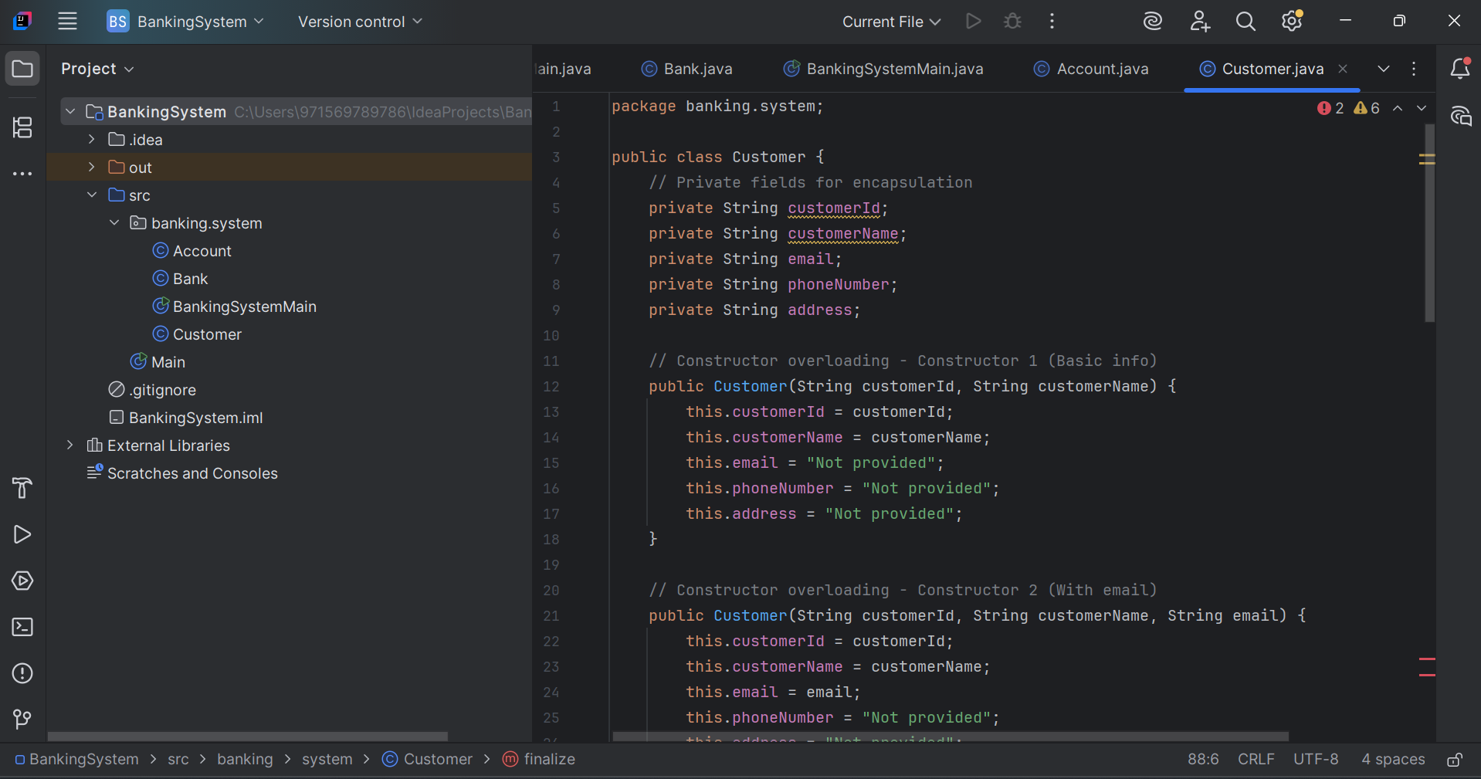

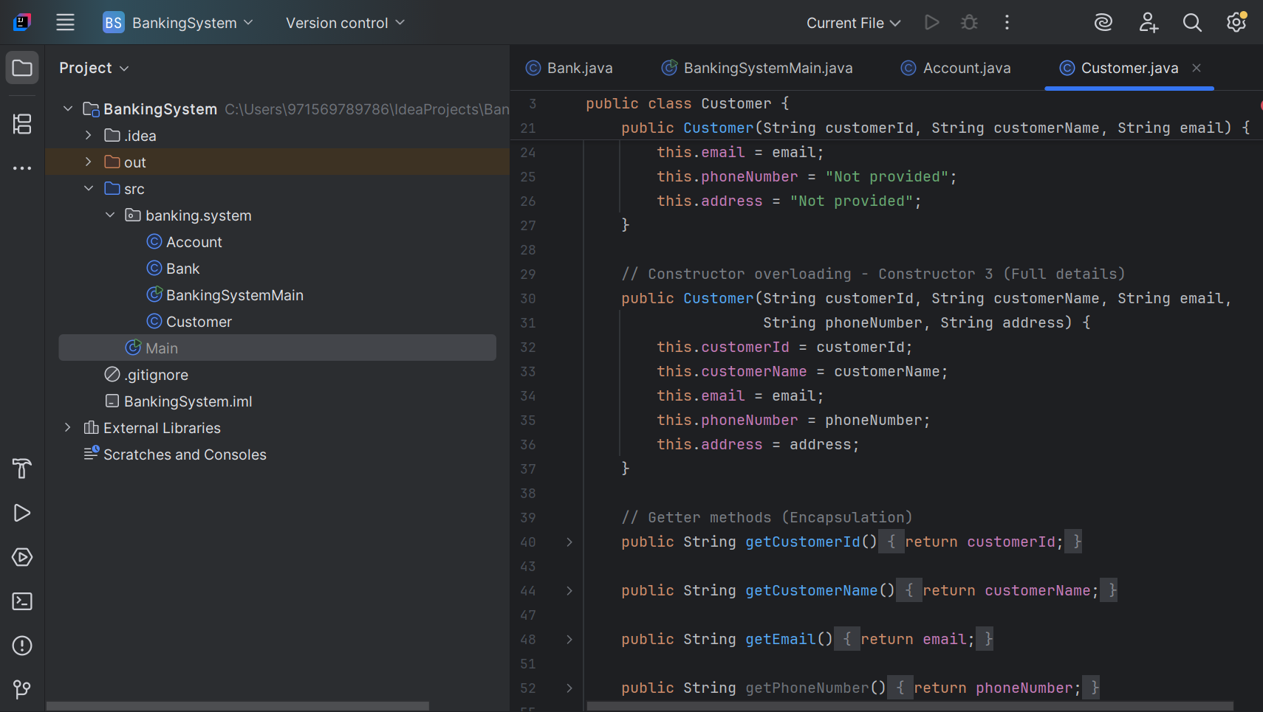

**File 2: Account.java**

package banking.system;  
public class Account {  
 // Private fields for encapsulation  
 private String accountNumber;  
 private String accountType;  
 private double balance;  
 private Customer accountHolder;  
  
 // Constructor overloading - Constructor 1 (Basic account)  
 public Account(String accountNumber, Customer accountHolder) {  
 this.accountNumber = accountNumber;  
 this.accountHolder = accountHolder;  
 this.accountType = "Savings";  
 this.balance = 0.0;  
 }  
  
 // Constructor overloading - Constructor 2 (With account type)  
 public Account(String accountNumber, Customer accountHolder, String accountType) {  
 this.accountNumber = accountNumber;  
 this.accountHolder = accountHolder;  
 this.accountType = accountType;  
 this.balance = 0.0;  
 }  
  
 // Constructor overloading - Constructor 3 (Full details)  
 public Account(String accountNumber, Customer accountHolder,  
 String accountType, double initialBalance) {  
 this.accountNumber = accountNumber;  
 this.accountHolder = accountHolder;  
 this.accountType = accountType;  
 this.balance = initialBalance;  
 }  
  
 // Getter methods (Encapsulation)  
 public String getAccountNumber() {  
 return accountNumber;  
 }  
  
 public String getAccountType() {  
 return accountType;  
 }  
  
 public double getBalance() {  
 return balance;  
 }  
  
 public Customer getAccountHolder() {  
 return accountHolder;  
 }  
  
 // Setter methods (Encapsulation)  
 public void setAccountType(String accountType) {  
 this.accountType = accountType;  
 }  
  
 // Banking operations  
 public void deposit(double amount) {  
 if (amount > 0) {  
 balance += amount;  
 System.*out*.println("Successfully deposited $" + amount);  
 System.*out*.println("Current balance: $" + balance);  
 } else {  
 System.*out*.println("Invalid deposit amount");  
 }  
 }  
  
 public void withdraw(double amount) {  
 if (amount > 0 && amount <= balance) {  
 balance -= amount;  
 System.*out*.println("Successfully withdrew $" + amount);  
 System.*out*.println("Current balance: $" + balance);  
 } else {  
 System.*out*.println("Invalid withdrawal amount or insufficient funds");  
 }  
 }  
  
 public void checkBalance() {  
 System.*out*.println("Current balance: $" + balance);  
 }  
  
 // Method to display account details  
 public void displayAccountInfo() {  
 System.*out*.println("\n=== Account Information ===");  
 System.*out*.println("Account Number: " + accountNumber);  
 System.*out*.println("Account Type: " + accountType);  
 System.*out*.println("Balance: $" + balance);  
 System.*out*.println("Account Holder Details:");  
 accountHolder.displayCustomerInfo();  
 }  
  
 // Destructor simulation using finalize()  
 @Override  
 protected void finalize() throws Throwable {  
 System.*out*.println("Account object " + accountNumber + " is being garbage collected");  
 super.finalize();  
 }  
}

**CODE SNIPPET:**

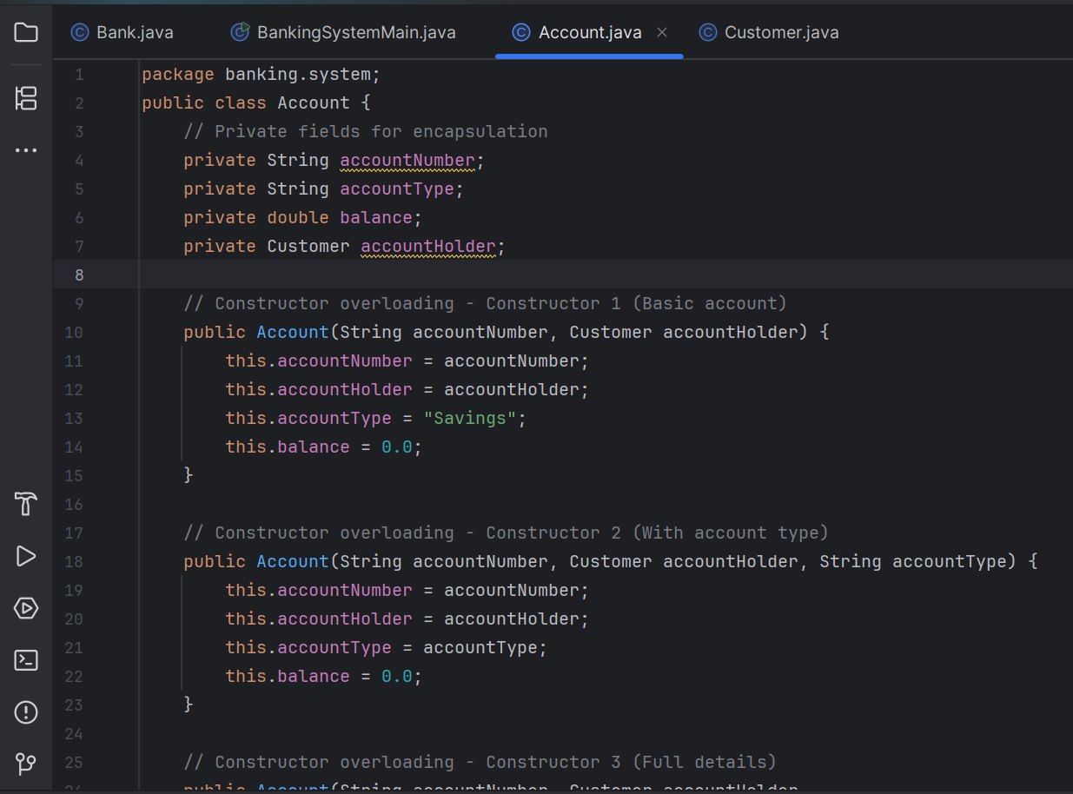

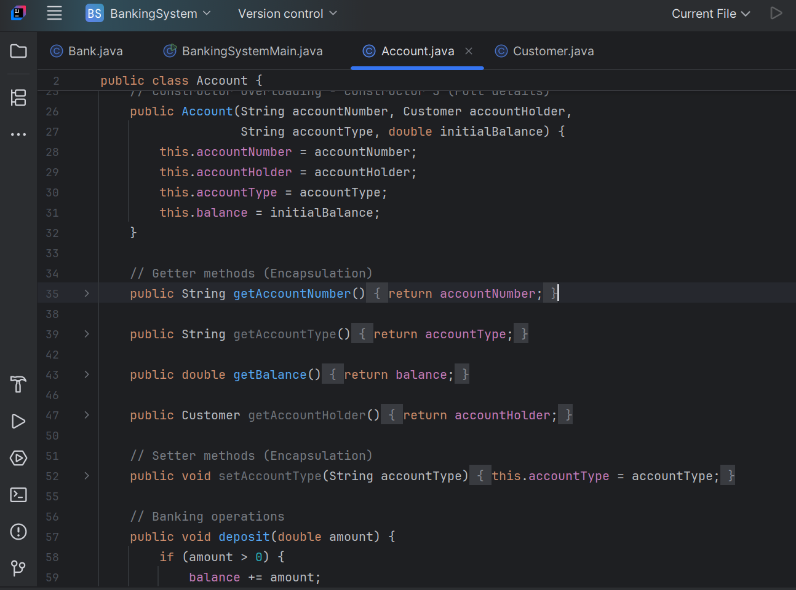

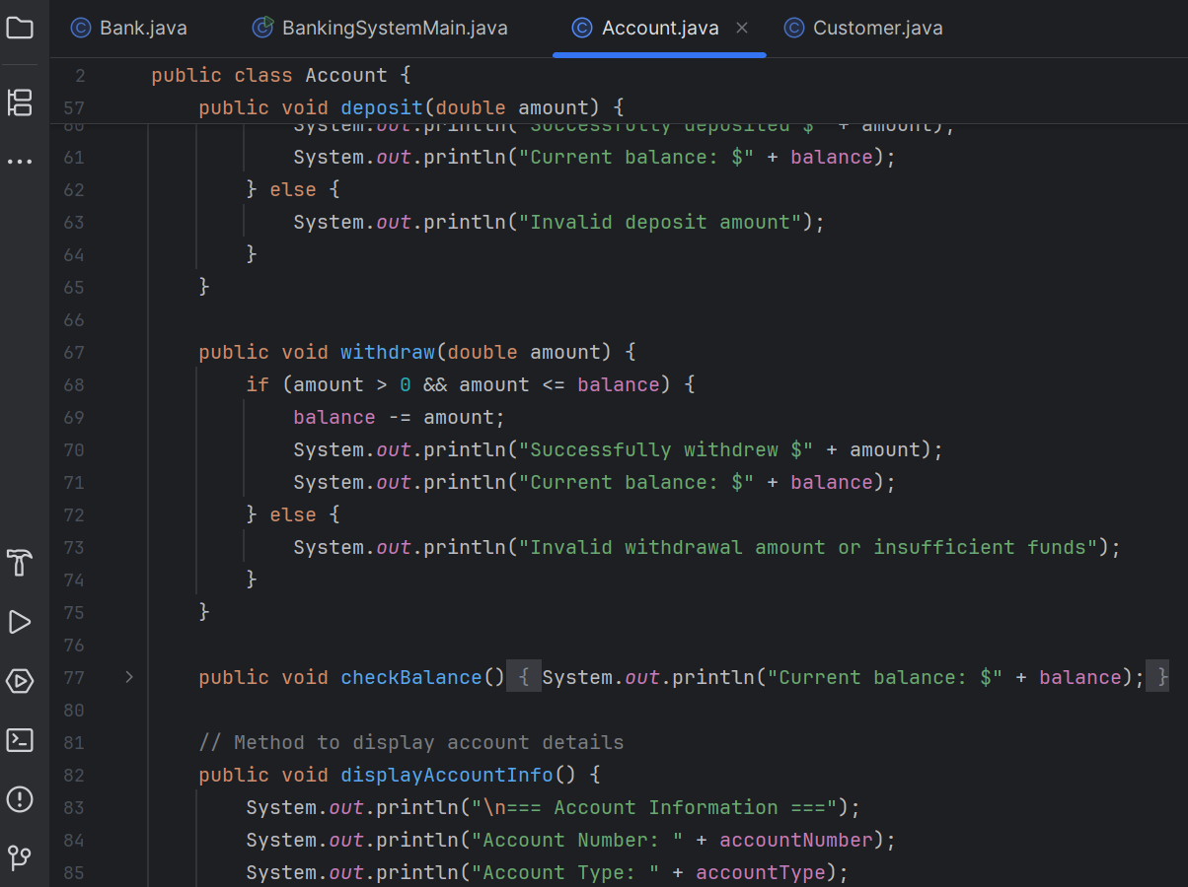

**File 3: Bank.java**

package banking.system;  
  
import java.util.ArrayList;  
import java.util.List;  
  
public class Bank {  
 // Private fields for encapsulation  
 private String bankName;  
 private String bankCode;  
 private List<Customer> customers;  
 private List<Account> accounts;  
  
 // Constructor overloading - Constructor 1 (Basic bank)  
 public Bank(String bankName) {  
 this.bankName = bankName;  
 this.bankCode = "DEFAULT";  
 this.customers = new ArrayList<>();  
 this.accounts = new ArrayList<>();  
 }  
  
 // Constructor overloading - Constructor 2 (With bank code)  
 public Bank(String bankName, String bankCode) {  
 this.bankName = bankName;  
 this.bankCode = bankCode;  
 this.customers = new ArrayList<>();  
 this.accounts = new ArrayList<>();  
 }  
  
 // Getter methods (Encapsulation)  
 public String getBankName() {  
 return bankName;  
 }  
  
 public String getBankCode() {  
 return bankCode;  
 }  
  
 public List<Customer> getCustomers() {  
 return new ArrayList<>(customers); // Return copy for encapsulation  
 }  
  
 public List<Account> getAccounts() {  
 return new ArrayList<>(accounts); // Return copy for encapsulation  
 }  
  
 // Bank operations  
 public void addCustomer(Customer customer) {  
 customers.add(customer);  
 System.*out*.println("Customer " + customer.getCustomerName() + " added successfully");  
 }  
  
 public void createAccount(Account account) {  
 accounts.add(account);  
 System.*out*.println("Account " + account.getAccountNumber() + " created successfully");  
 }  
  
 public Customer findCustomer(String customerId) {  
 for (Customer customer : customers) {  
 if (customer.getCustomerId().equals(customerId)) {  
 return customer;  
 }  
 }  
 return null;  
 }  
  
 public Account findAccount(String accountNumber) {  
 for (Account account : accounts) {  
 if (account.getAccountNumber().equals(accountNumber)) {  
 return account;  
 }  
 }  
 return null;  
 }  
  
 // Method to display bank information  
 public void displayBankInfo() {  
 System.*out*.println("\n=== Bank Information ===");  
 System.*out*.println("Bank Name: " + bankName);  
 System.*out*.println("Bank Code: " + bankCode);  
 System.*out*.println("Total Customers: " + customers.size());  
 System.*out*.println("Total Accounts: " + accounts.size());  
 }  
  
 public void displayAllCustomers() {  
 System.*out*.println("\n=== All Customers ===");  
 for (Customer customer : customers) {  
 customer.displayCustomerInfo();  
 System.*out*.println("---");  
 }  
 }  
  
 public void displayAllAccounts() {  
 System.*out*.println("\n=== All Accounts ===");  
 for (Account account : accounts) {  
 account.displayAccountInfo();  
 System.*out*.println("---");  
 }  
 }  
  
 // Destructor simulation using finalize()  
 @Override  
 protected void finalize() throws Throwable {  
 System.*out*.println("Bank object " + bankName + " is being garbage collected");  
 super.finalize();  
 }  
}

**CODE SNIPPET:**

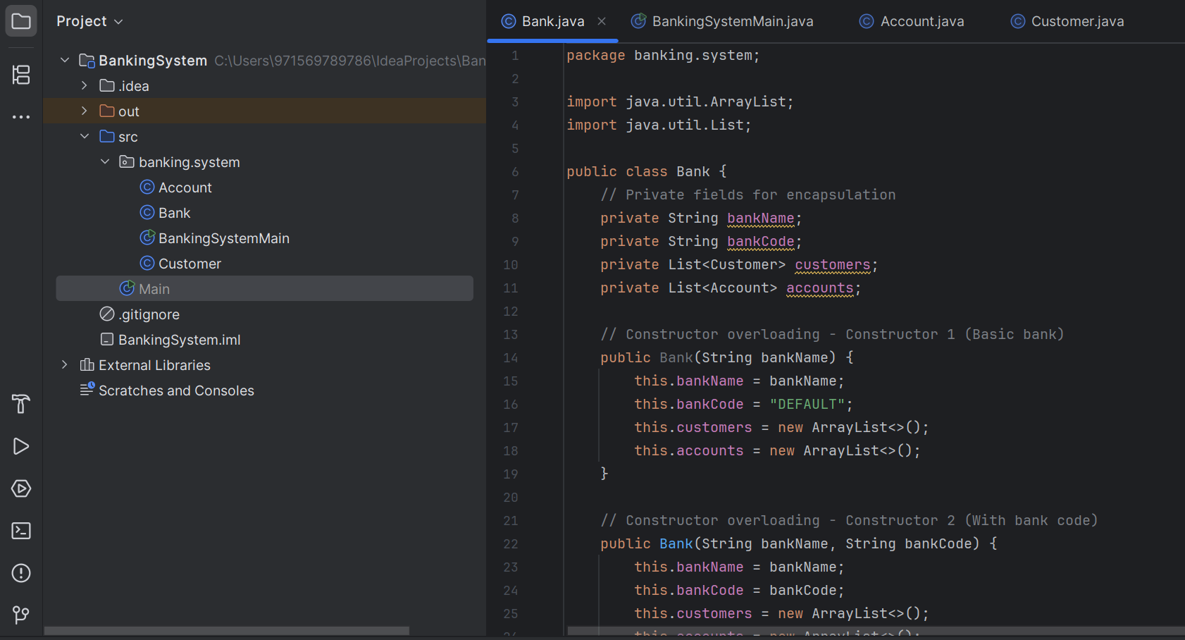

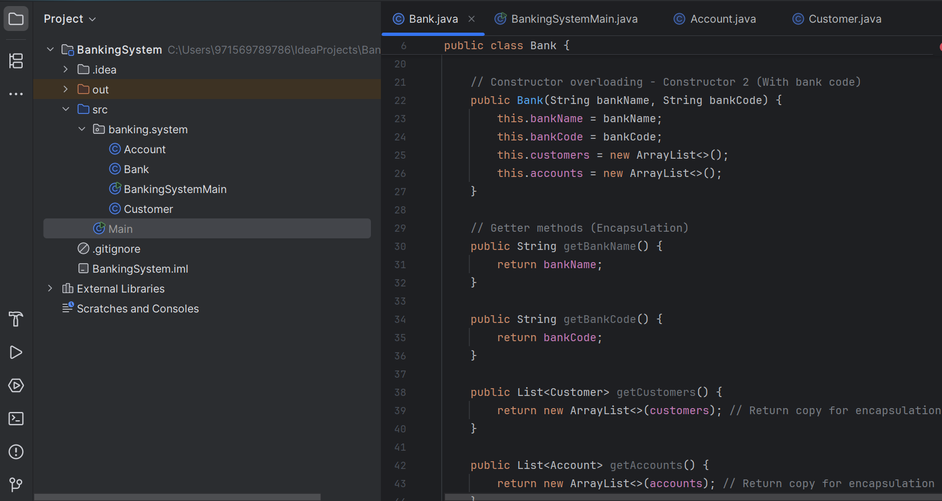

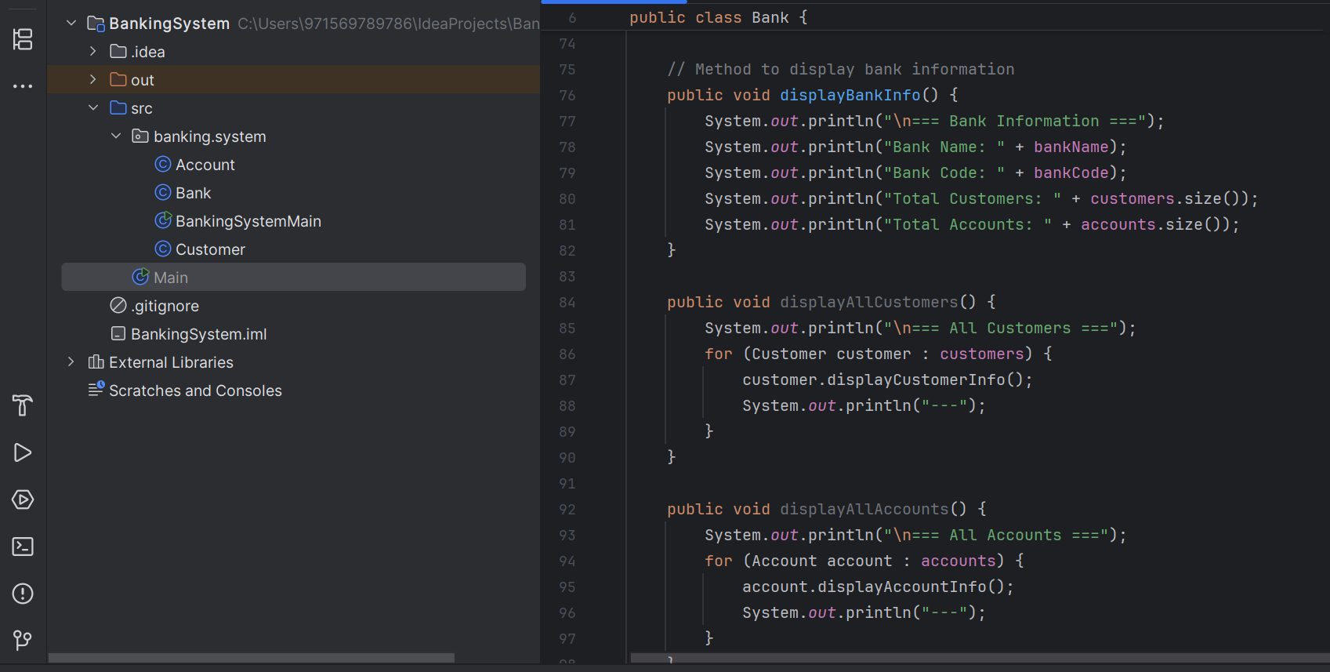

**File 4: BankingSystemMain.java**

package banking.system;  
  
public class BankingSystemMain {  
 public static void main(String[] args) {  
 System.*out*.println("=== Banking System Demo ===\n");  
  
 // Create bank using constructor overloading  
 Bank bank = new Bank("Tech Bank", "TB001");  
 bank.displayBankInfo();  
  
 // Create customers using constructor overloading  
 System.*out*.println("\n--- Creating Customers ---");  
 Customer customer1 = new Customer("C001", "John Doe");  
 Customer customer2 = new Customer("C002", "Jane Smith", "jane@email.com");  
 Customer customer3 = new Customer("C003", "Bob Johnson", "bob@email.com",  
 "555-1234", "123 Main St");  
  
 // Add customers to bank  
 bank.addCustomer(customer1);  
 bank.addCustomer(customer2);  
 bank.addCustomer(customer3);  
  
 // Create accounts using constructor overloading  
 System.*out*.println("\n--- Creating Accounts ---");  
 Account account1 = new Account("ACC001", customer1);  
 Account account2 = new Account("ACC002", customer2, "Checking");  
 Account account3 = new Account("ACC003", customer3, "Savings", 1000.0);  
  
 // Add accounts to bank  
 bank.createAccount(account1);  
 bank.createAccount(account2);  
 bank.createAccount(account3);  
  
 // Demonstrate banking operations  
 System.*out*.println("\n--- Banking Operations ---");  
 account1.deposit(500.0);  
 account1.withdraw(100.0);  
 account1.checkBalance();  
  
 account2.deposit(750.0);  
 account2.withdraw(200.0);  
  
 account3.deposit(250.0);  
 account3.withdraw(150.0);  
  
 // Display all information  
 System.*out*.println("\n--- Final Bank Status ---");  
 bank.displayBankInfo();  
  
 System.*out*.println("\n--- Account Details ---");  
 account1.displayAccountInfo();  
 account2.displayAccountInfo();  
 account3.displayAccountInfo();  
  
 // Demonstrate encapsulation  
 System.*out*.println("\n--- Demonstrating Encapsulation ---");  
 System.*out*.println("Customer 1 Email (before update): " + customer1.getEmail());  
 customer1.setEmail("john.doe@email.com");  
 System.*out*.println("Customer 1 Email (after update): " + customer1.getEmail());  
  
 // Search functionality  
 System.*out*.println("\n--- Search Functionality ---");  
 Customer foundCustomer = bank.findCustomer("C002");  
 if (foundCustomer != null) {  
 System.*out*.println("Found customer: " + foundCustomer.getCustomerName());  
 }  
  
 Account foundAccount = bank.findAccount("ACC003");  
 if (foundAccount != null) {  
 System.*out*.println("Found account with balance: $" + foundAccount.getBalance());  
 }  
  
 // Simulate garbage collection to show finalize() method  
 System.*out*.println("\n--- Simulating Garbage Collection ---");  
 customer1 = null;  
 account1 = null;  
 System.*gc*(); // Suggest garbage collection  
  
 try {  
 Thread.*sleep*(1000); // Wait for potential finalize() calls  
 } catch (InterruptedException e) {  
 Thread.*currentThread*().interrupt();  
 }  
  
 System.*out*.println("\n=== Banking System Demo Complete ===");  
 }  
}

**CODE SNIPPET:**

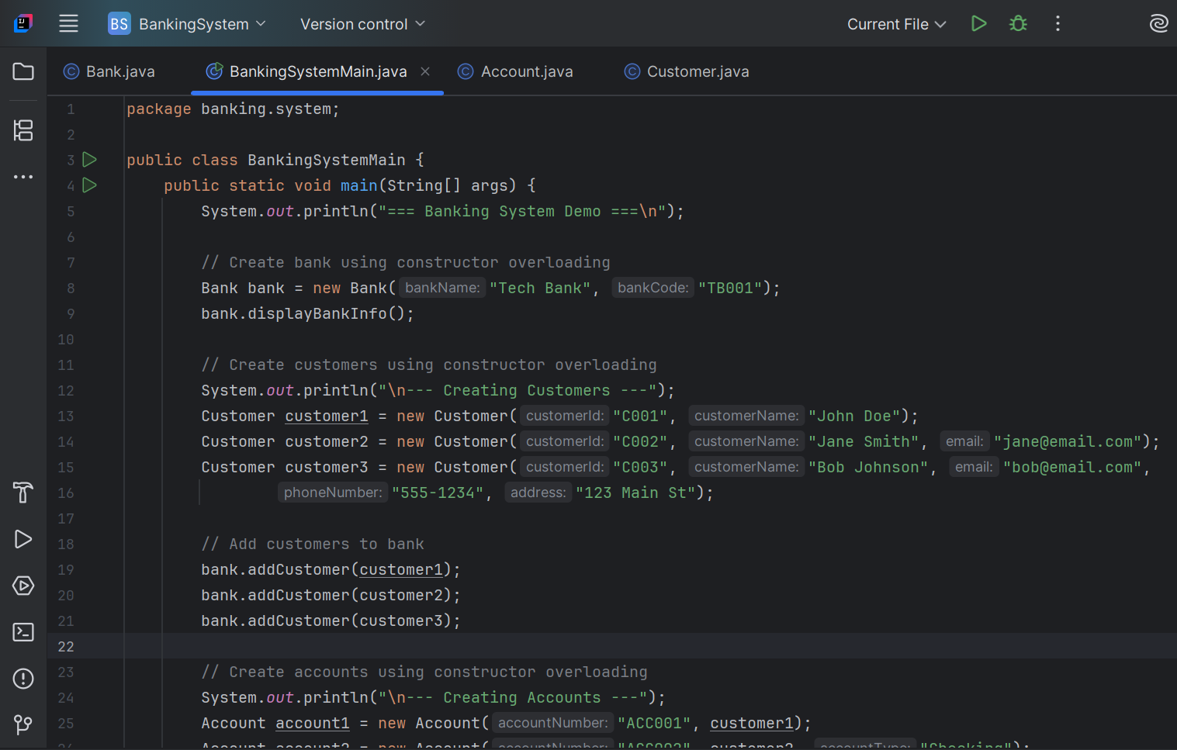

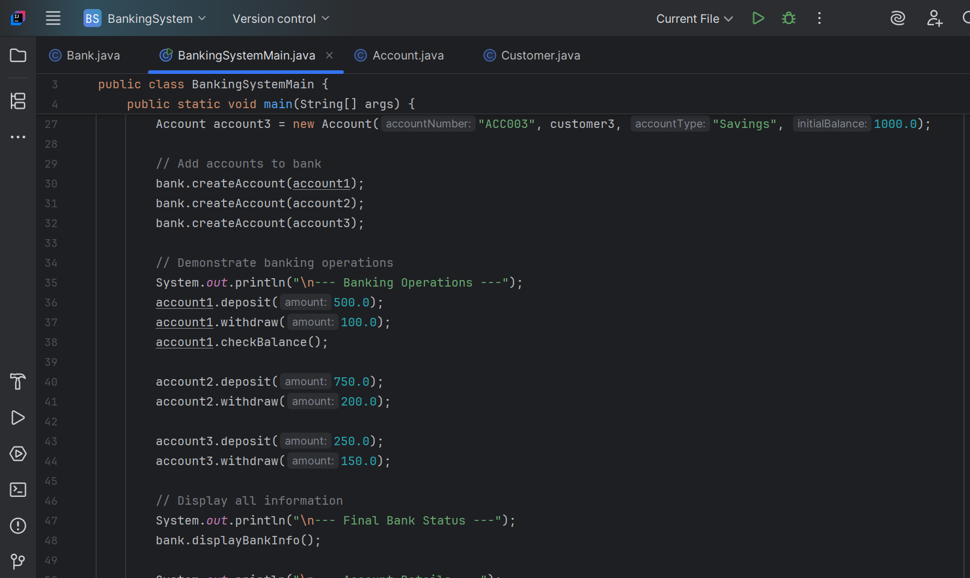

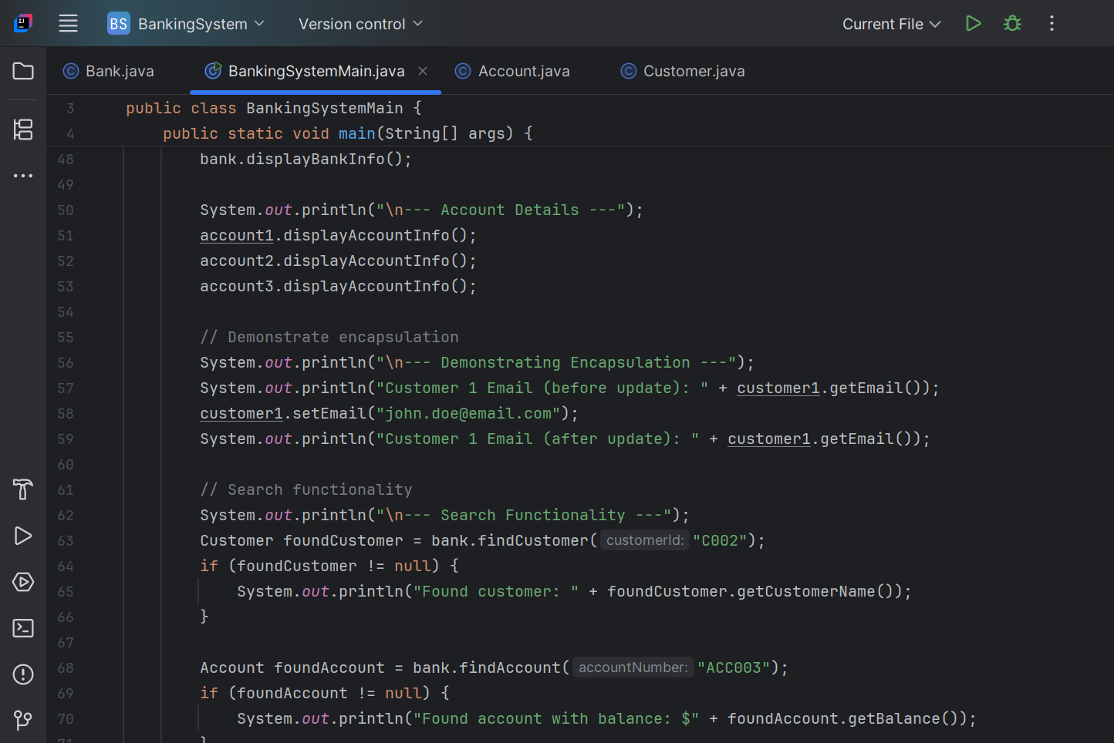

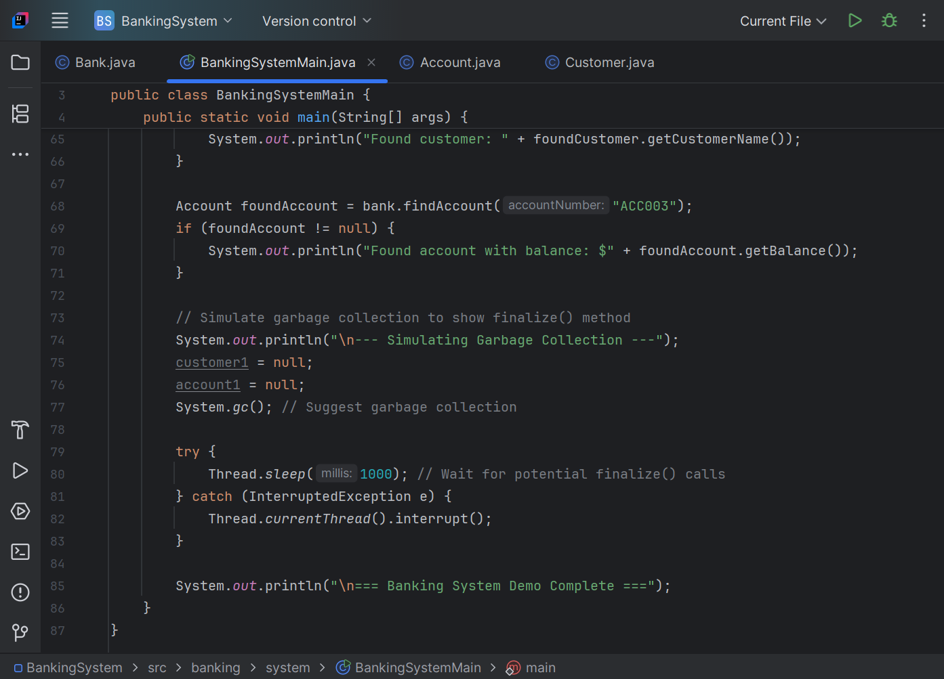

**Expected Output Features:**

* Bank information display
* Customer management
* Account operations (deposit, withdraw, balance check)
* Search functionality
* Encapsulation demonstration
* Garbage collection simulation

## **OUTPUT SNIPPET:**

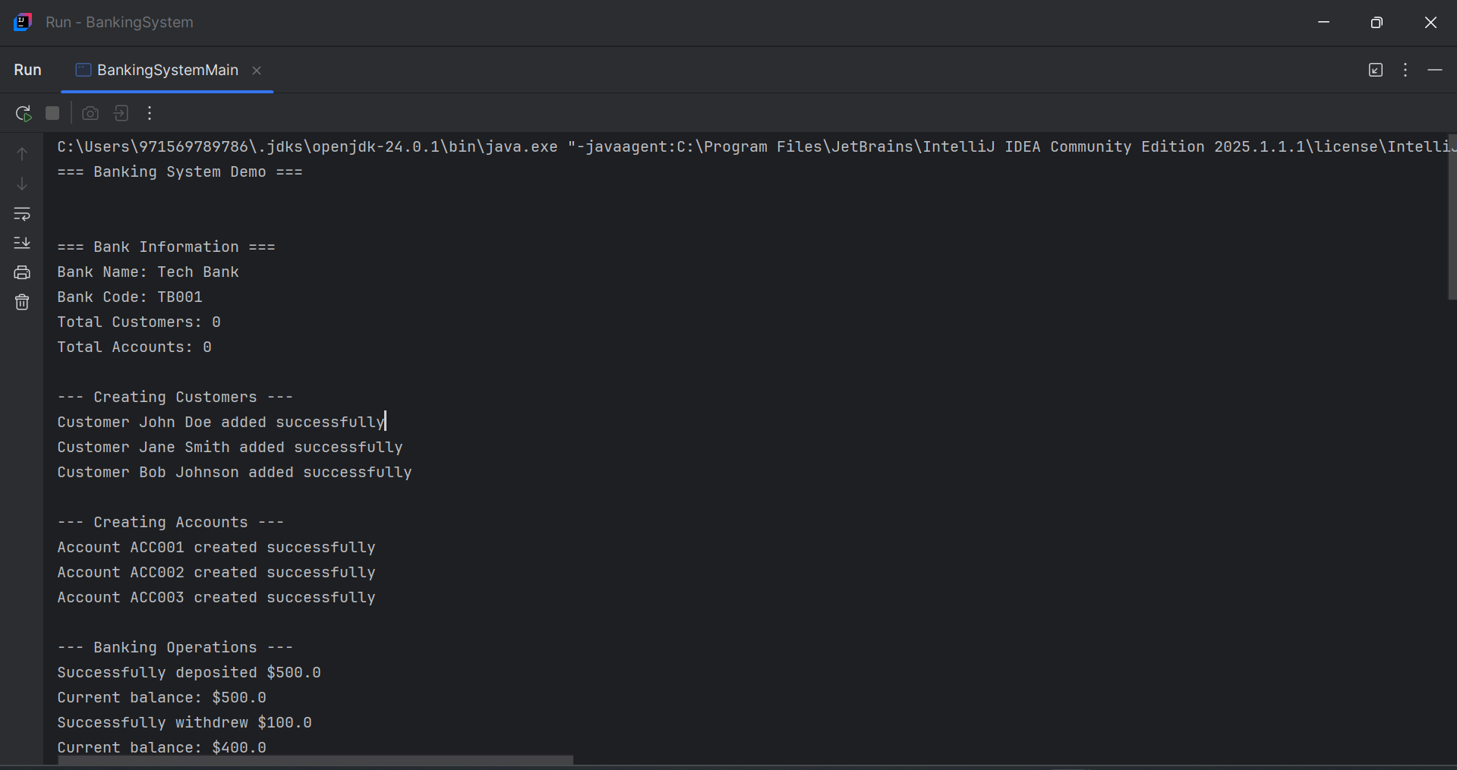

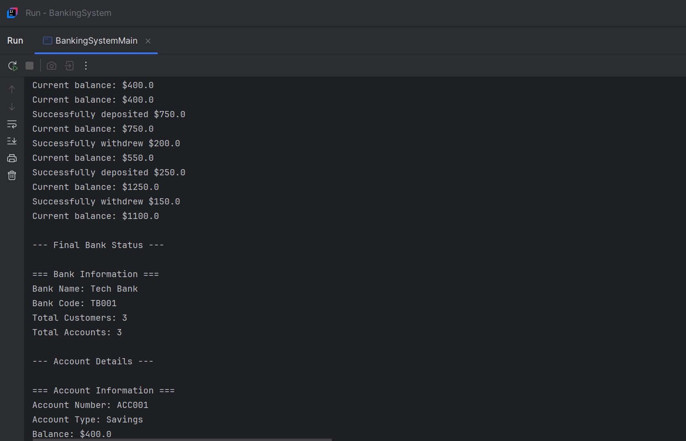

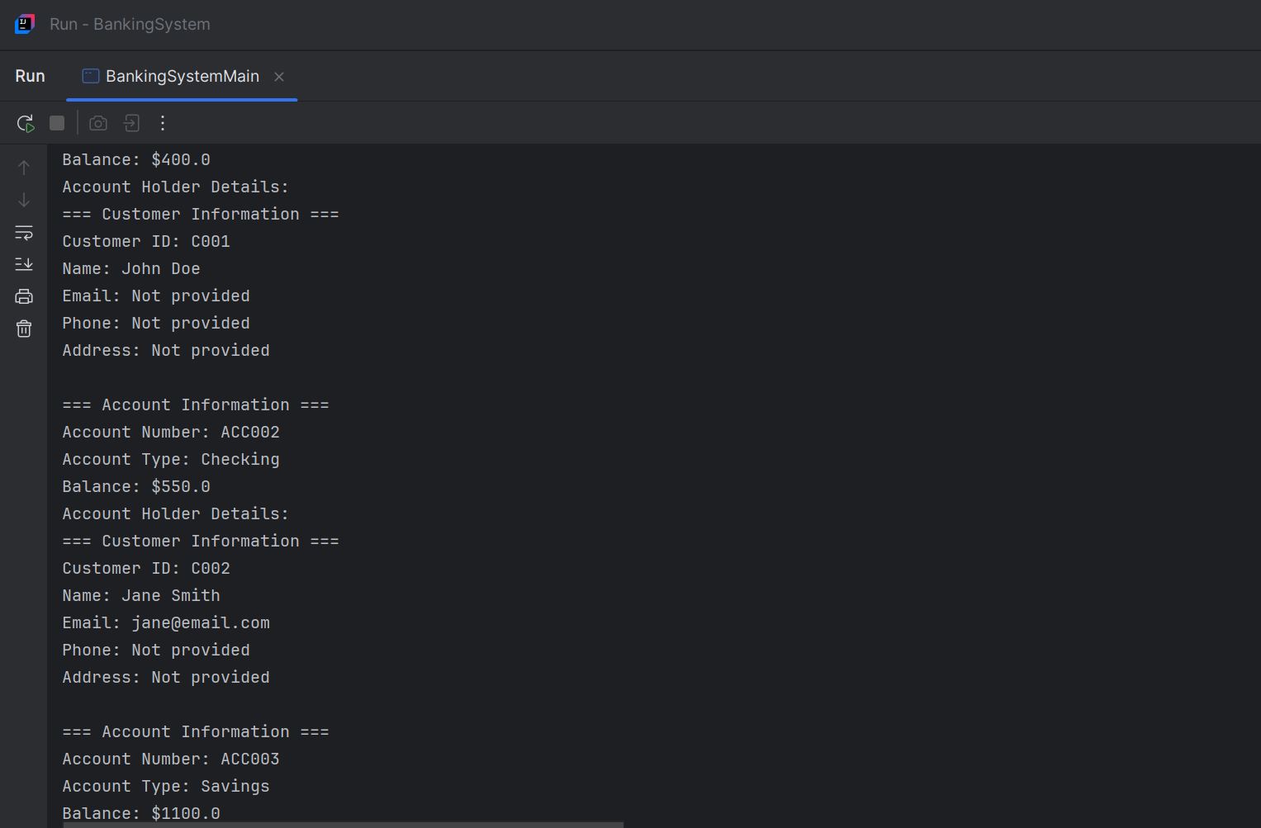

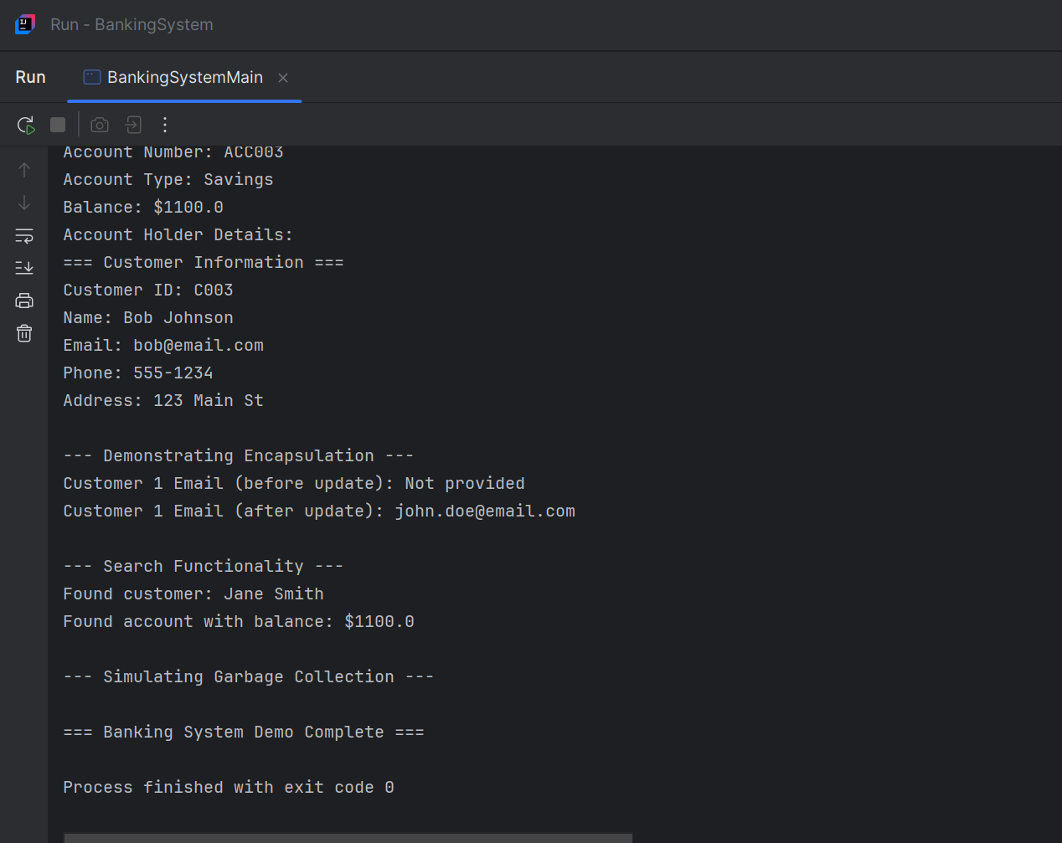

# **Task 2: Inheritance and Polymorphism Task**

**Objective:** Demonstrate inheritance, abstract classes, interfaces, and method overriding.

**Java Code**

// Employee Management System

// Demonstrates Inheritance, Polymorphism, Abstract Classes, and Interfaces

// ===============================

// INTERFACE DECLARATION

// ===============================

/**

* TaxPayer interface - defines contract for tax calculation

* All employees must implement this interface

*/

interface TaxPayer {

double calculateTax();

String getTaxCategory();

void displayTaxInfo();

}

// ===============================

// ABSTRACT SUPERCLASS

// ===============================

/**

* Abstract Employee class - serves as base class for all employees

* Contains common attributes and methods, with abstract methods to be implemented

*/

abstract class Employee implements TaxPayer {

// Protected attributes - accessible to subclasses

protected String name;

protected int employeeId;

protected double baseSalary;

protected String department;

protected int yearsOfExperience;

// Constructor

public Employee(String name, int employeeId, double baseSalary,

String department, int yearsOfExperience) {

this.name = name;

this.employeeId = employeeId;

this.baseSalary = baseSalary;

this.department = department;

this.yearsOfExperience = yearsOfExperience;

}

// Concrete methods - inherited by all subclasses

public String getName() { return name; }

public int getEmployeeId() { return employeeId; }

public double getBaseSalary() { return baseSalary; }

public String getDepartment() { return department; }

public int getYearsOfExperience() { return yearsOfExperience; }

public void setBaseSalary(double baseSalary) { this.baseSalary = baseSalary; }

// Abstract methods - must be implemented by subclasses

public abstract double calculateSalary();

public abstract String getJobTitle();

public abstract void displayEmployeeInfo();

public abstract double getPerformanceBonus();

// Common method that can be overridden

public void work() {

System.out.println(name + " is working in " + department + " department.");

}

// Default implementation of TaxPayer interface

@Override

public void displayTaxInfo() {

System.out.println("Tax Category: " + getTaxCategory());

System.out.println("Annual Tax: $" + String.format("%.2f", calculateTax()));

}

}

// ===============================

// CONCRETE SUBCLASSES

// ===============================

/**

* Manager class - extends Employee

* Demonstrates inheritance and method overriding

*/

class Manager extends Employee {

private int teamSize;

private double managementBonus;

public Manager(String name, int employeeId, double baseSalary,

String department, int yearsOfExperience,

int teamSize, double managementBonus) {

super(name, employeeId, baseSalary, department, yearsOfExperience);

this.teamSize = teamSize;

this.managementBonus = managementBonus;

}

// Implementing abstract methods

@Override

public double calculateSalary() {

return baseSalary + managementBonus + (teamSize * 500) + getPerformanceBonus();

}

@Override

public String getJobTitle() {

return "Manager";

}

@Override

public double getPerformanceBonus() {

return baseSalary * 0.15; // 15% performance bonus

}

@Override

public void displayEmployeeInfo() {

System.out.println("=== MANAGER INFORMATION ===");

System.out.println("Name: " + name);

System.out.println("Employee ID: " + employeeId);

System.out.println("Job Title: " + getJobTitle());

System.out.println("Department: " + department);

System.out.println("Years of Experience: " + yearsOfExperience);

System.out.println("Team Size: " + teamSize);

System.out.println("Base Salary: $" + String.format("%.2f", baseSalary));

System.out.println("Management Bonus: $" + String.format("%.2f", managementBonus));

System.out.println("Total Salary: $" + String.format("%.2f", calculateSalary()));

}

// Method overriding

@Override

public void work() {

System.out.println(name + " is managing a team of " + teamSize +

" members in " + department + " department.");

}

// Implementing TaxPayer interface

@Override

public double calculateTax() {

double totalSalary = calculateSalary();

return totalSalary * 0.25; // 25% tax rate for managers

}

@Override

public String getTaxCategory() {

return "High Income - Management";

}

// Manager-specific methods

public void conductMeeting() {

System.out.println(name + " is conducting a team meeting.");

}

public void evaluateTeam() {

System.out.println(name + " is evaluating team performance.");

}

// Getters

public int getTeamSize() { return teamSize; }

public double getManagementBonus() { return managementBonus; }

}

/**

* Developer class - extends Employee

* Demonstrates inheritance and polymorphism

*/

class Developer extends Employee {

private String programmingLanguage;

private int projectsCompleted;

private String specialization;

public Developer(String name, int employeeId, double baseSalary,

String department, int yearsOfExperience,

String programmingLanguage, int projectsCompleted,

String specialization) {

super(name, employeeId, baseSalary, department, yearsOfExperience);

this.programmingLanguage = programmingLanguage;

this.projectsCompleted = projectsCompleted;

this.specialization = specialization;

}

// Implementing abstract methods

@Override

public double calculateSalary() {

return baseSalary + (projectsCompleted * 1000) + getPerformanceBonus();

}

@Override

public String getJobTitle() {

return "Software Developer";

}

@Override

public double getPerformanceBonus() {

return baseSalary * 0.10; // 10% performance bonus

}

@Override

public void displayEmployeeInfo() {

System.out.println("=== DEVELOPER INFORMATION ===");

System.out.println("Name: " + name);

System.out.println("Employee ID: " + employeeId);

System.out.println("Job Title: " + getJobTitle());

System.out.println("Department: " + department);

System.out.println("Years of Experience: " + yearsOfExperience);

System.out.println("Programming Language: " + programmingLanguage);

System.out.println("Projects Completed: " + projectsCompleted);

System.out.println("Specialization: " + specialization);

System.out.println("Base Salary: $" + String.format("%.2f", baseSalary));

System.out.println("Total Salary: $" + String.format("%.2f", calculateSalary()));

}

// Method overriding

@Override

public void work() {

System.out.println(name + " is coding in " + programmingLanguage +

" for " + specialization + " projects.");

}

// Implementing TaxPayer interface

@Override

public double calculateTax() {

double totalSalary = calculateSalary();

return totalSalary * 0.20; // 20% tax rate for developers

}

@Override

public String getTaxCategory() {

return "Medium Income - Technical";

}

// Developer-specific methods

public void writeCode() {

System.out.println(name + " is writing code in " + programmingLanguage);

}

public void debugApplication() {

System.out.println(name + " is debugging the application.");

}

// Getters

public String getProgrammingLanguage() { return programmingLanguage; }

public int getProjectsCompleted() { return projectsCompleted; }

public String getSpecialization() { return specialization; }

}

/**

* Intern class - extends Employee

* Demonstrates inheritance with different behavior

*/

class Intern extends Employee {

private String university;

private String mentor;

private int internshipDuration; // in months

public Intern(String name, int employeeId, double baseSalary,

String department, int yearsOfExperience,

String university, String mentor, int internshipDuration) {

super(name, employeeId, baseSalary, department, yearsOfExperience);

this.university = university;

this.mentor = mentor;

this.internshipDuration = internshipDuration;

}

// Implementing abstract methods

@Override

public double calculateSalary() {

return baseSalary + getPerformanceBonus();

}

@Override

public String getJobTitle() {

return "Intern";

}

@Override

public double getPerformanceBonus() {

return 500; // Fixed bonus for interns

}

@Override

public void displayEmployeeInfo() {

System.out.println("=== INTERN INFORMATION ===");

System.out.println("Name: " + name);

System.out.println("Employee ID: " + employeeId);

System.out.println("Job Title: " + getJobTitle());

System.out.println("Department: " + department);

System.out.println("University: " + university);

System.out.println("Mentor: " + mentor);

System.out.println("Internship Duration: " + internshipDuration + " months");

System.out.println("Base Salary: $" + String.format("%.2f", baseSalary));

System.out.println("Total Salary: $" + String.format("%.2f", calculateSalary()));

}

// Method overriding

@Override

public void work() {

System.out.println(name + " is learning and working under " + mentor +

" in " + department + " department.");

}

// Implementing TaxPayer interface

@Override

public double calculateTax() {

double totalSalary = calculateSalary();

return totalSalary * 0.10; // 10% tax rate for interns

}

@Override

public String getTaxCategory() {

return "Low Income - Student";

}

// Intern-specific methods

public void attendTraining() {

System.out.println(name + " is attending training sessions.");

}

public void submitReport() {

System.out.println(name + " is submitting weekly progress report to " + mentor);

}

// Getters

public String getUniversity() { return university; }

public String getMentor() { return mentor; }

public int getInternshipDuration() { return internshipDuration; }

}

// ===============================

// MAIN CLASS - DEMONSTRATION

// ===============================

public class EmployeeManagementSystem {

public static void main(String[] args) {

System.out.println("=".repeat(60));

System.out.println("EMPLOYEE MANAGEMENT SYSTEM DEMONSTRATION");

System.out.println("=".repeat(60));

// Creating instances of different employee types

Manager manager = new Manager("Alice Johnson", 1001, 80000, "IT", 8, 10, 15000);

Developer developer = new Developer("Bob Smith", 1002, 70000, "Development", 5,

"Java", 12, "Backend Development");

Intern intern = new Intern("Charlie Brown", 1003, 2000, "IT", 0,

"MIT", "Alice Johnson", 6);

// Array of employees for polymorphism demonstration

Employee[] employees = {manager, developer, intern};

System.out.println("\n1. POLYMORPHISM DEMONSTRATION");

System.out.println("-".repeat(40));

// Polymorphism - calling overridden methods

for (Employee emp : employees) {

System.out.println("Employee: " + emp.getName());

System.out.println("Job Title: " + emp.getJobTitle());

System.out.println("Salary: $" + String.format("%.2f", emp.calculateSalary()));

emp.work(); // Polymorphic method call

System.out.println();

}

System.out.println("\n2. DETAILED EMPLOYEE INFORMATION");

System.out.println("-".repeat(40));

// Display detailed information for each employee

manager.displayEmployeeInfo();

System.out.println();

developer.displayEmployeeInfo();

System.out.println();

intern.displayEmployeeInfo();

System.out.println();

System.out.println("\n3. INTERFACE IMPLEMENTATION (TaxPayer)");

System.out.println("-".repeat(40));

// Demonstrating interface implementation

TaxPayer[] taxPayers = {manager, developer, intern};

for (TaxPayer tp : taxPayers) {

Employee emp = (Employee) tp; // Downcasting

System.out.println("Employee: " + emp.getName());

tp.displayTaxInfo();

System.out.println();

}

System.out.println("\n4. TYPE CASTING DEMONSTRATION");

System.out.println("-".repeat(40));

// Upcasting (implicit)

Employee empRef = manager; // Upcasting Manager to Employee

System.out.println("Upcasted Manager to Employee:");

System.out.println("Name: " + empRef.getName());

System.out.println("Job Title: " + empRef.getJobTitle());

System.out.println("Salary: $" + String.format("%.2f", empRef.calculateSalary()));

// Downcasting (explicit)

if (empRef instanceof Manager) {

Manager downcastedManager = (Manager) empRef; // Downcasting

System.out.println("Downcasted back to Manager:");

System.out.println("Team Size: " + downcastedManager.getTeamSize());

downcastedManager.conductMeeting();

}

System.out.println("\n5. SPECIFIC METHODS DEMONSTRATION");

System.out.println("-".repeat(40));

// Manager-specific methods

manager.conductMeeting();

manager.evaluateTeam();

// Developer-specific methods

developer.writeCode();

developer.debugApplication();

// Intern-specific methods

intern.attendTraining();

intern.submitReport();

System.out.println("\n6. RUNTIME POLYMORPHISM WITH instanceof");

System.out.println("-".repeat(40));

for (Employee emp : employees) {

System.out.println("Employee: " + emp.getName());

if (emp instanceof Manager) {

Manager mgr = (Manager) emp;

System.out.println("This is a Manager with team size: " + mgr.getTeamSize());

} else if (emp instanceof Developer) {

Developer dev = (Developer) emp;

System.out.println("This is a Developer specializing in: " + dev.getSpecialization());

} else if (emp instanceof Intern) {

Intern int_emp = (Intern) emp;

System.out.println("This is an Intern from: " + int_emp.getUniversity());

}

System.out.println();

}

System.out.println("\n7. SALARY COMPARISON");

System.out.println("-".repeat(40));

double totalPayroll = 0;

for (Employee emp : employees) {

double salary = emp.calculateSalary();

totalPayroll += salary;

System.out.println(emp.getName() + " (" + emp.getJobTitle() + "): $" +

String.format("%.2f", salary));

}

System.out.println("Total Payroll: $" + String.format("%.2f", totalPayroll));

System.out.println("\n8. TAX CALCULATION SUMMARY");

System.out.println("-".repeat(40));

double totalTax = 0;

for (Employee emp : employees) {

double tax = emp.calculateTax();

totalTax += tax;

System.out.println(emp.getName() + " - Tax: $" + String.format("%.2f", tax) +

" (" + emp.getTaxCategory() + ")");

}

System.out.println("Total Tax Collected: $" + String.format("%.2f", totalTax));

System.out.println("\n" + "=".repeat(60));

System.out.println("DEMONSTRATION COMPLETE");

System.out.println("=".repeat(60));

}

}

**CODE SNIPPET:**

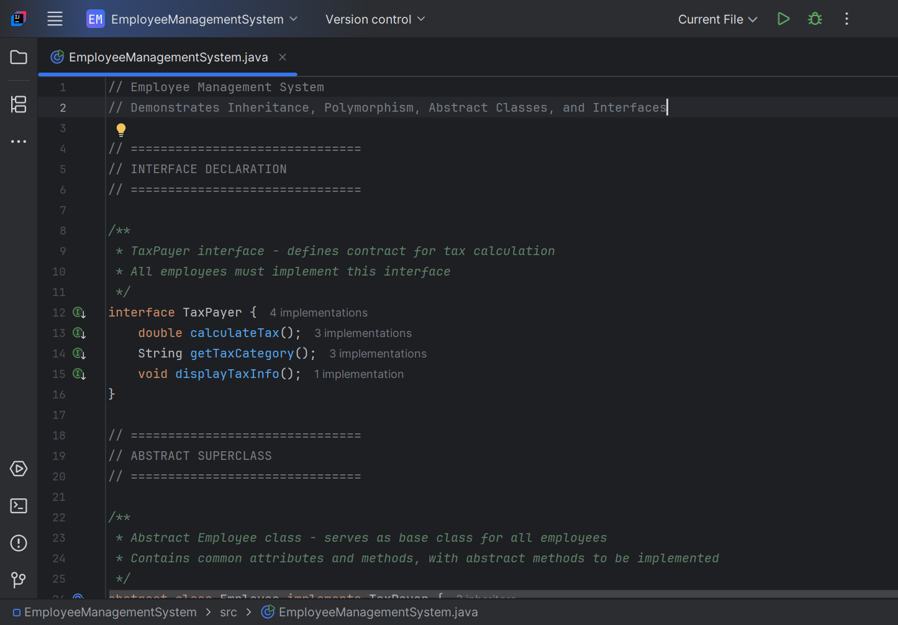

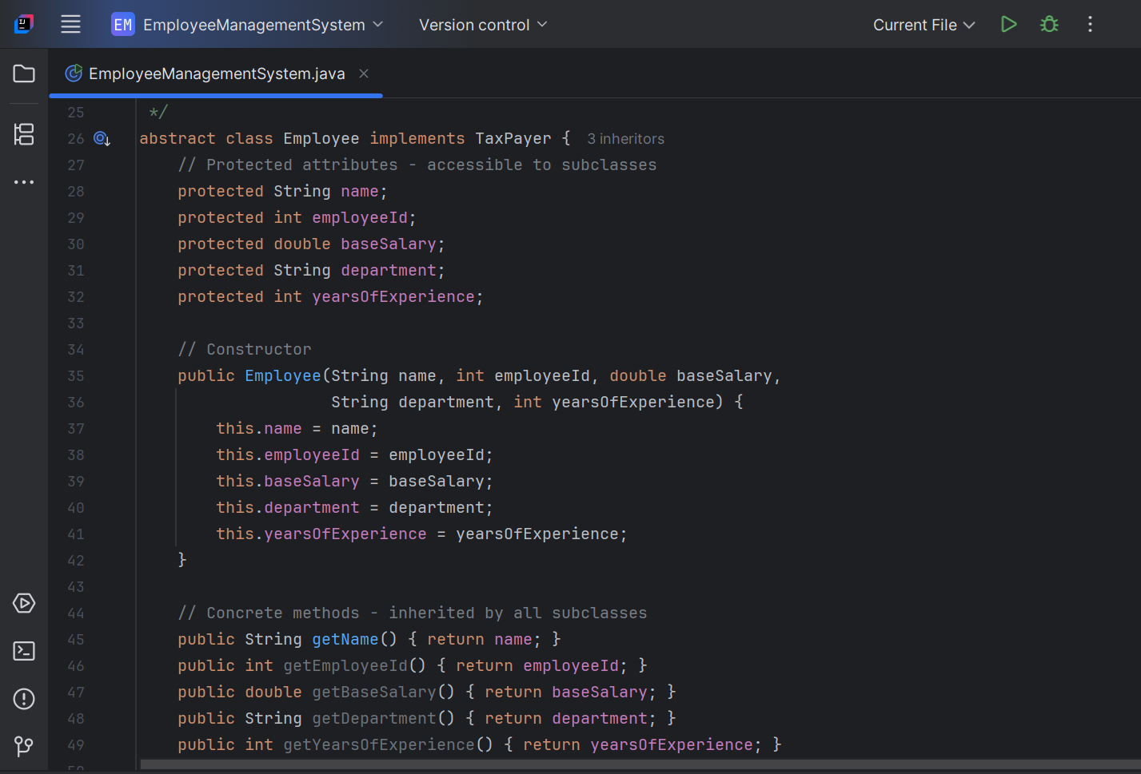

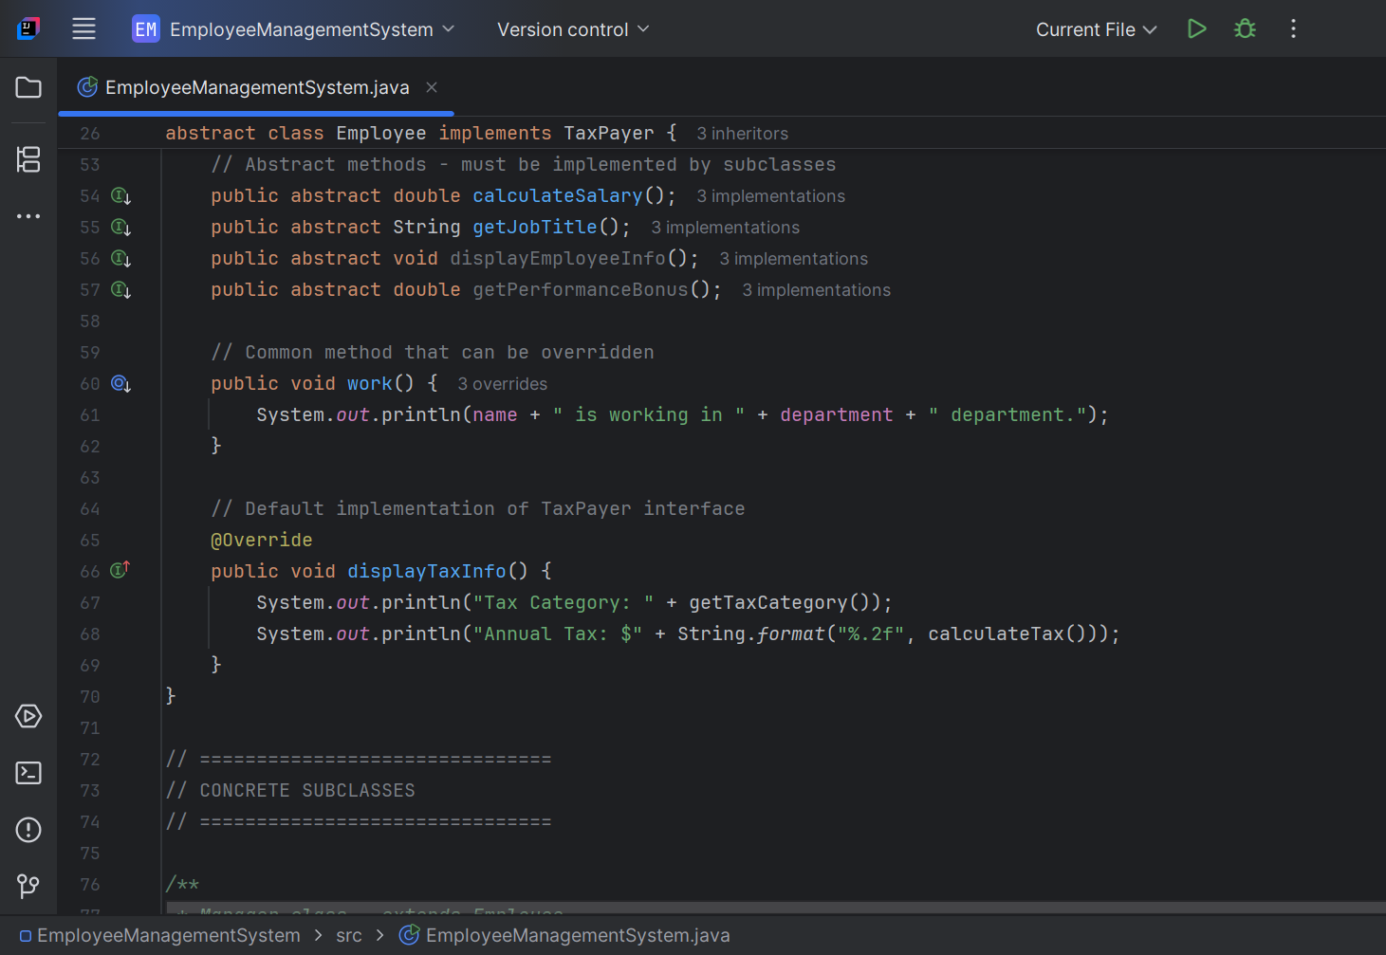

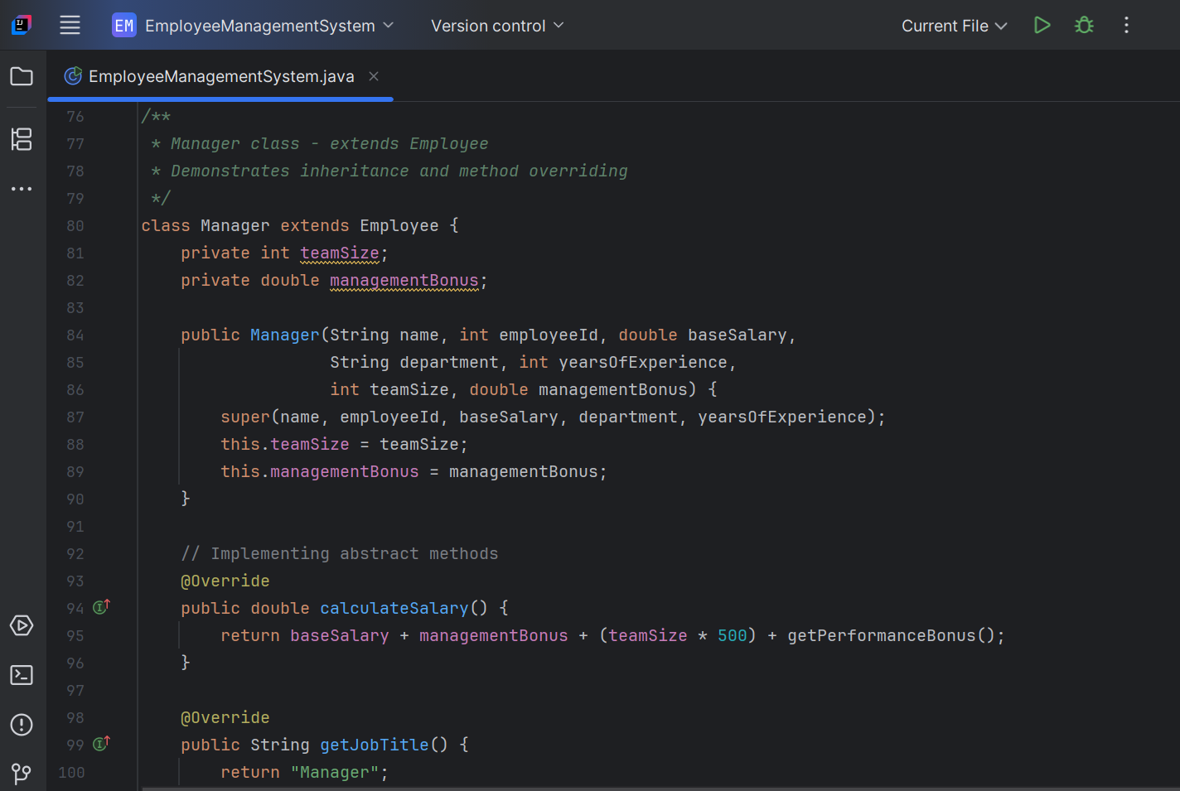

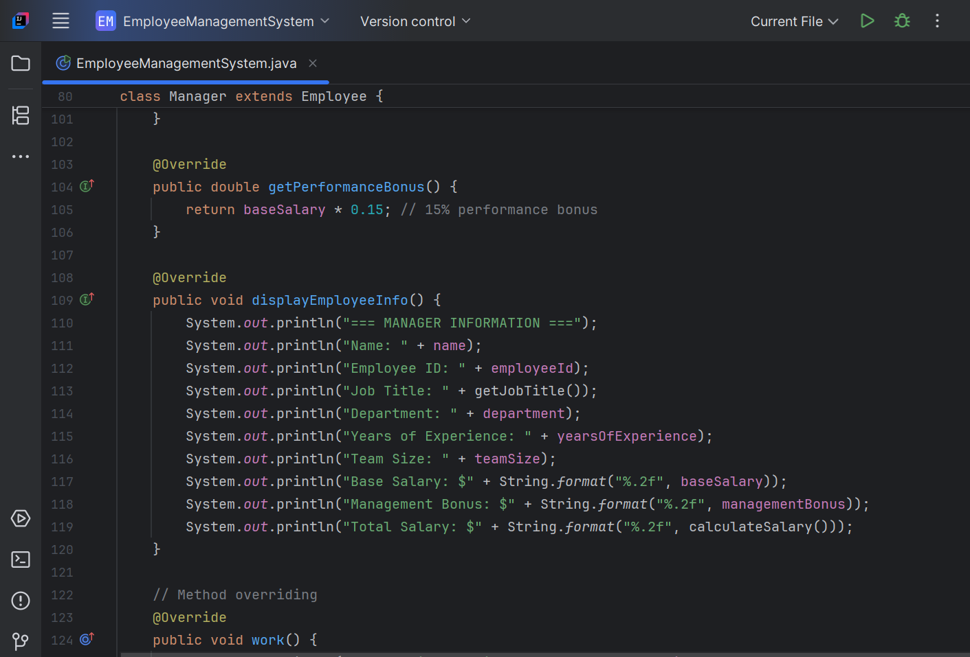

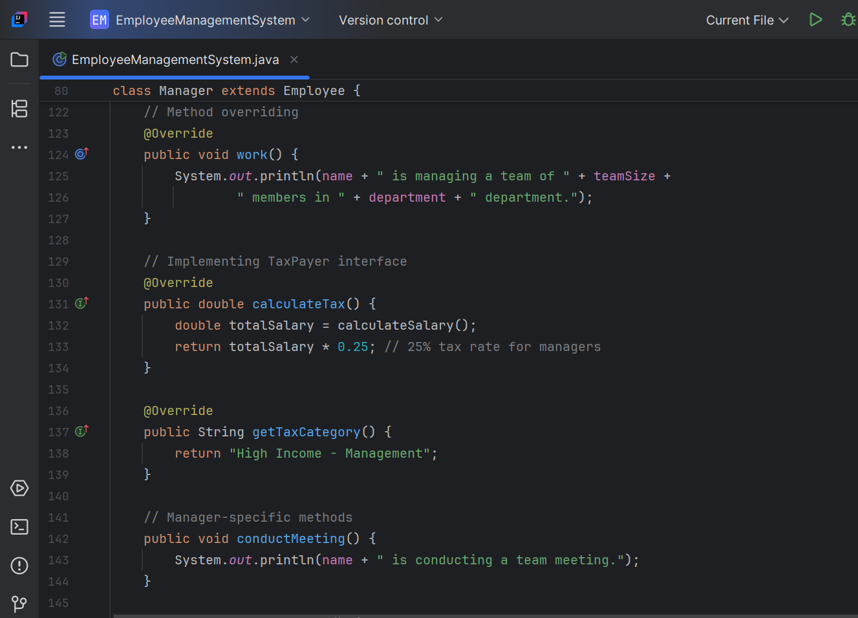

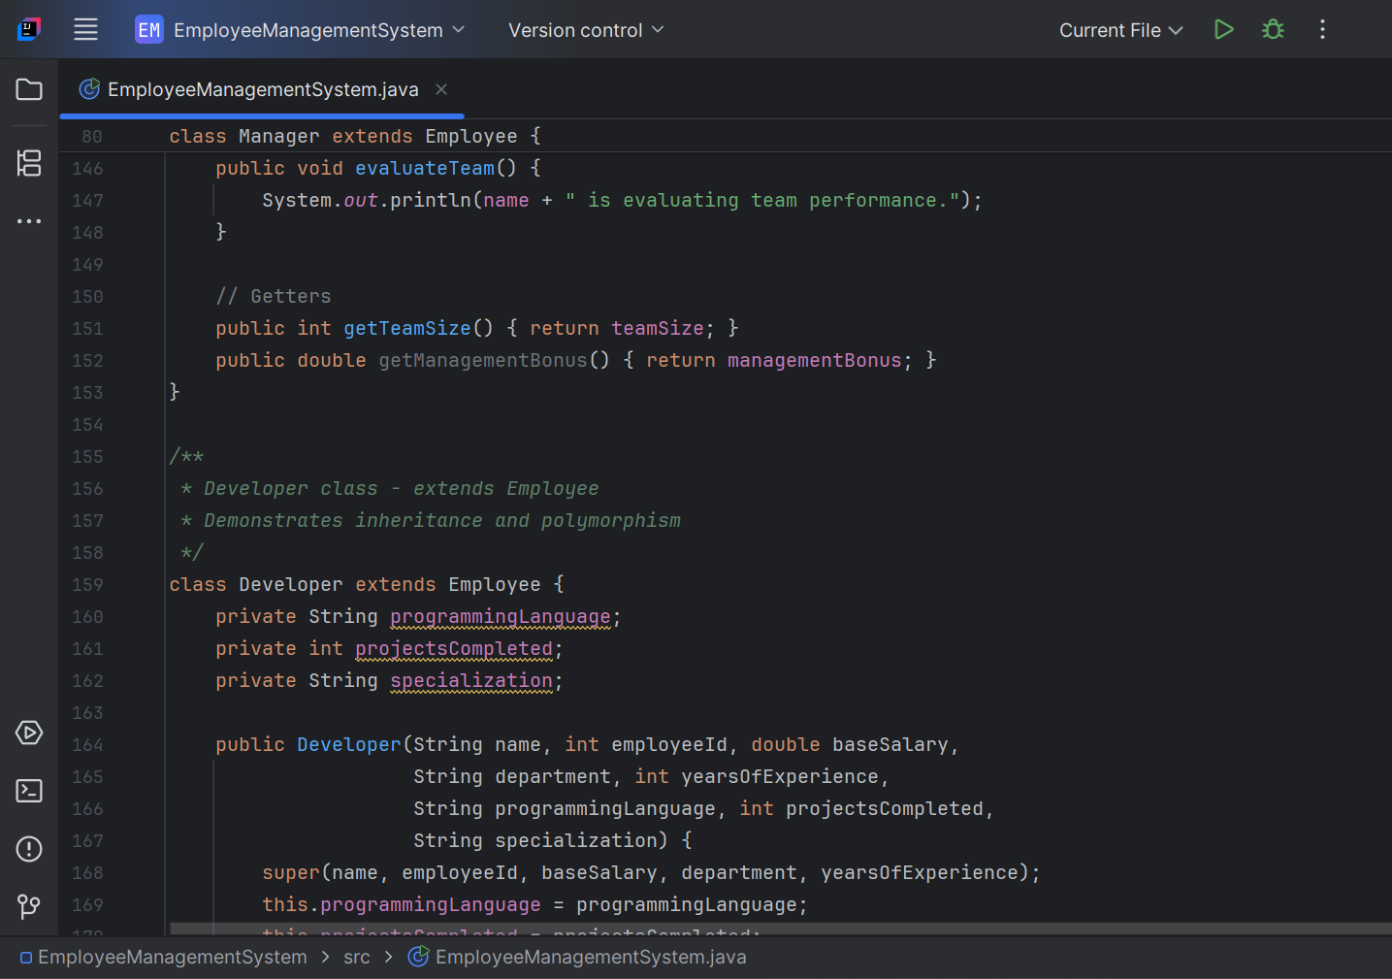

**Key OOP Concepts Implemented:**

1. **Classes/ Objects**

* **4 classes:** Bank, Customer, Account, BankingSystemMain
* Multiple objects created and used

1. **Encapsulation**

* All fields are private
* Public getter/setter methods
* Data protection through controlled access

1. **Constructor Overloading and Finalize**

* Each class has multiple constructors
* Finalize () method implemented in all classes
* Demonstrates different initialization options

1. **Clean Structure and Output**

* Well-organized package structure
* Clear method names and documentation
* Comprehensive output display
* Professional formatting

**Expected Output Features:**

* Bank information display
* Customer management
* Account operations (deposit, withdraw, balance check)
* Search functionality
* Encapsulation demonstration
* Garbage collection simulation

The program demonstrates all required OOP concepts with a realistic banking system scenario.

## **OUTPUT SNIPPET**

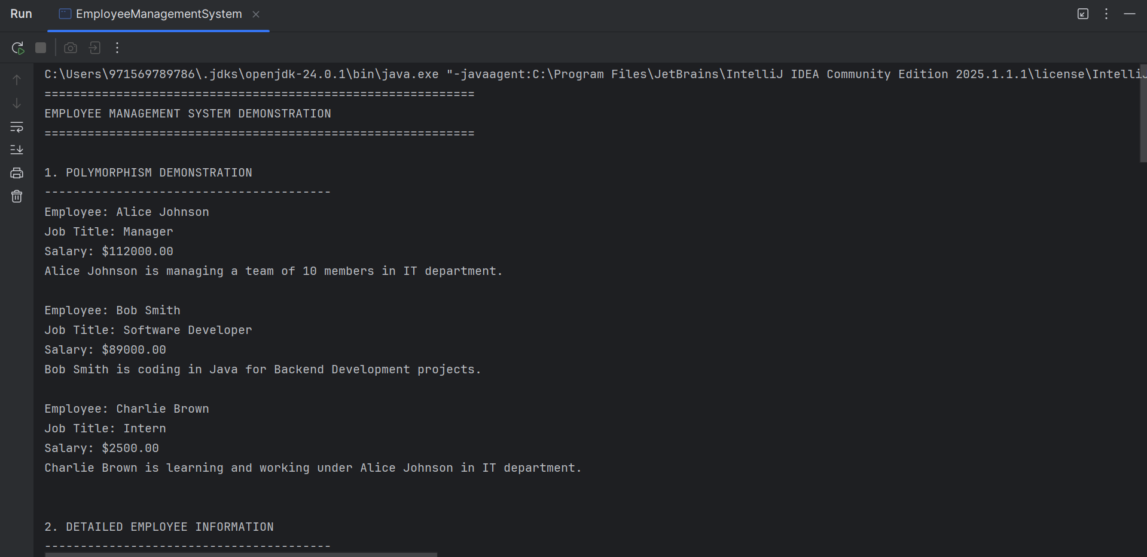

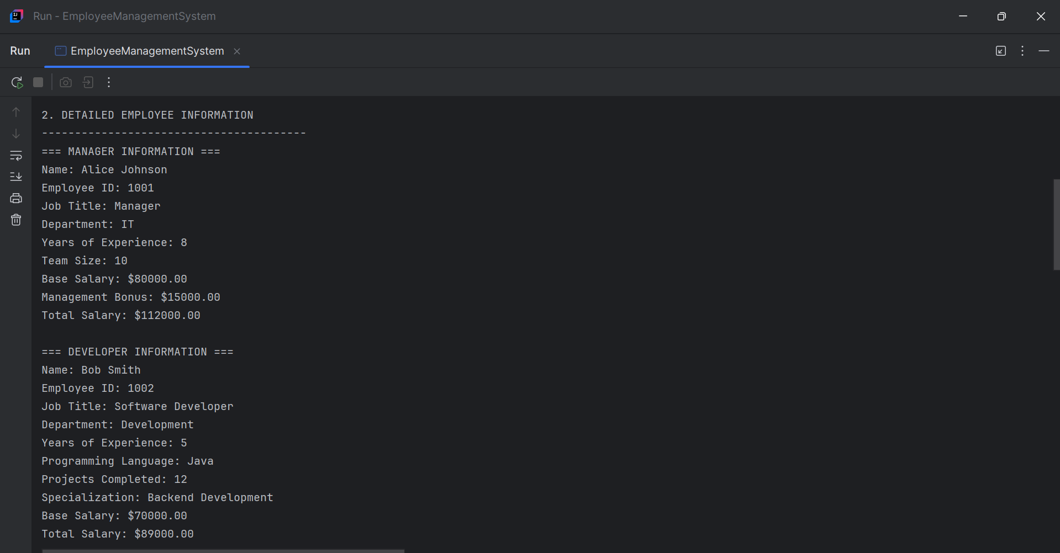

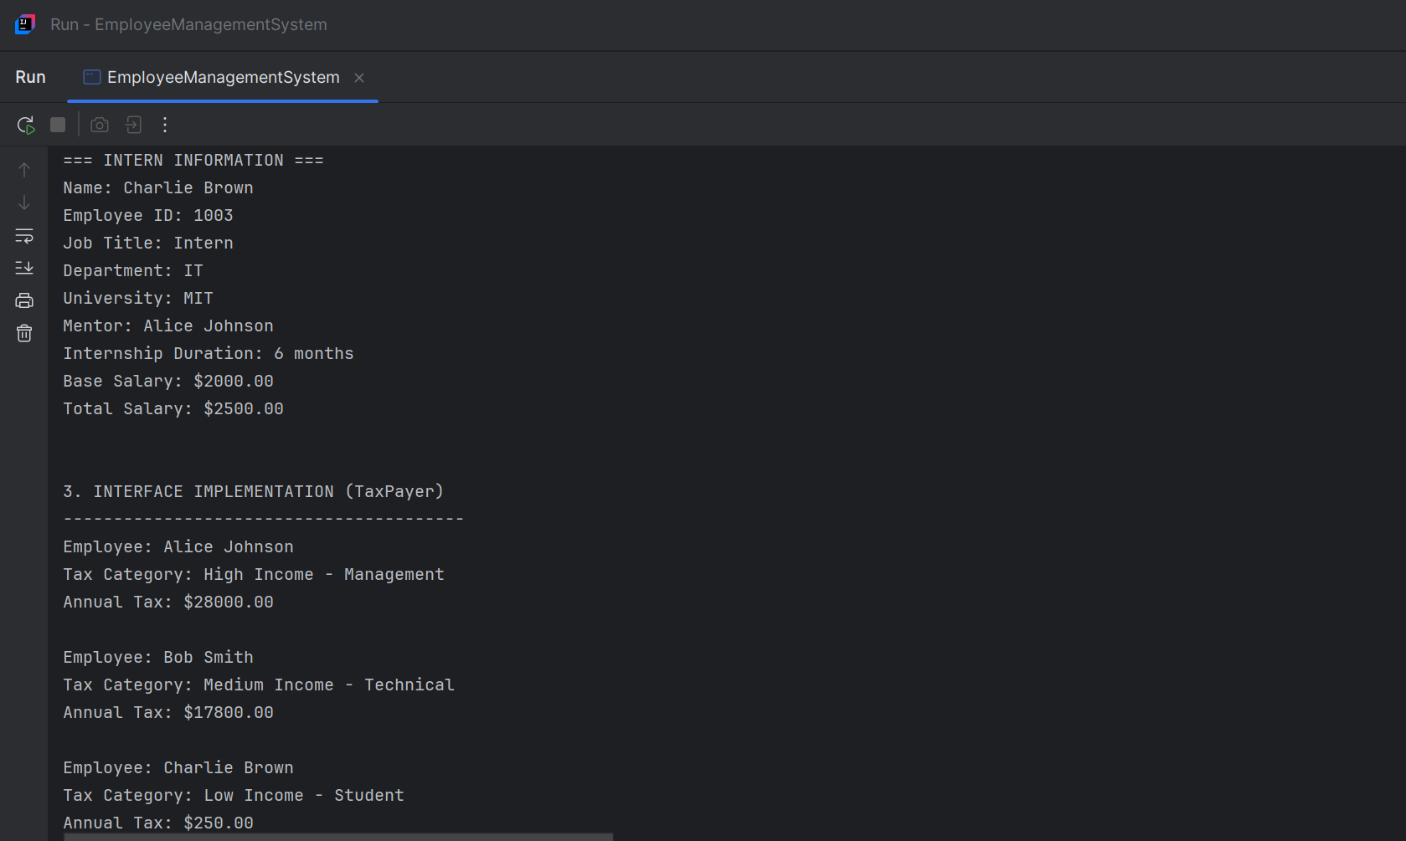

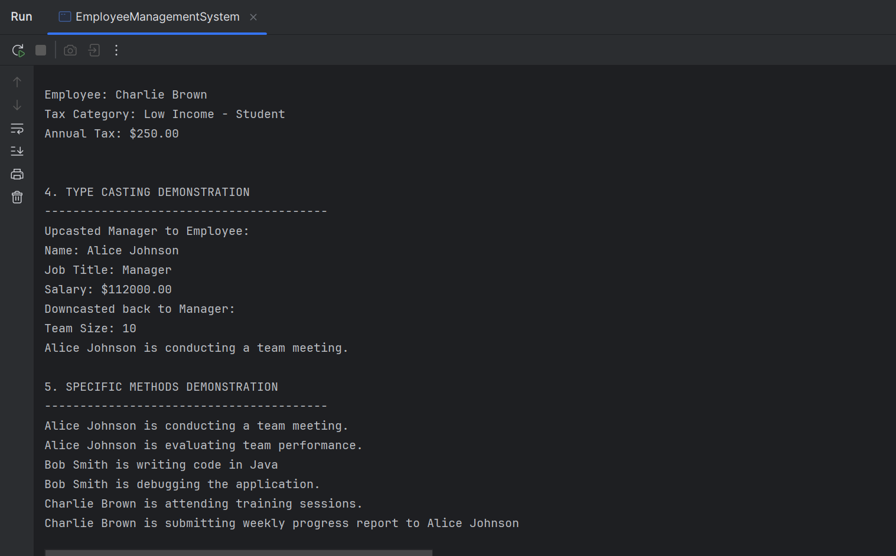

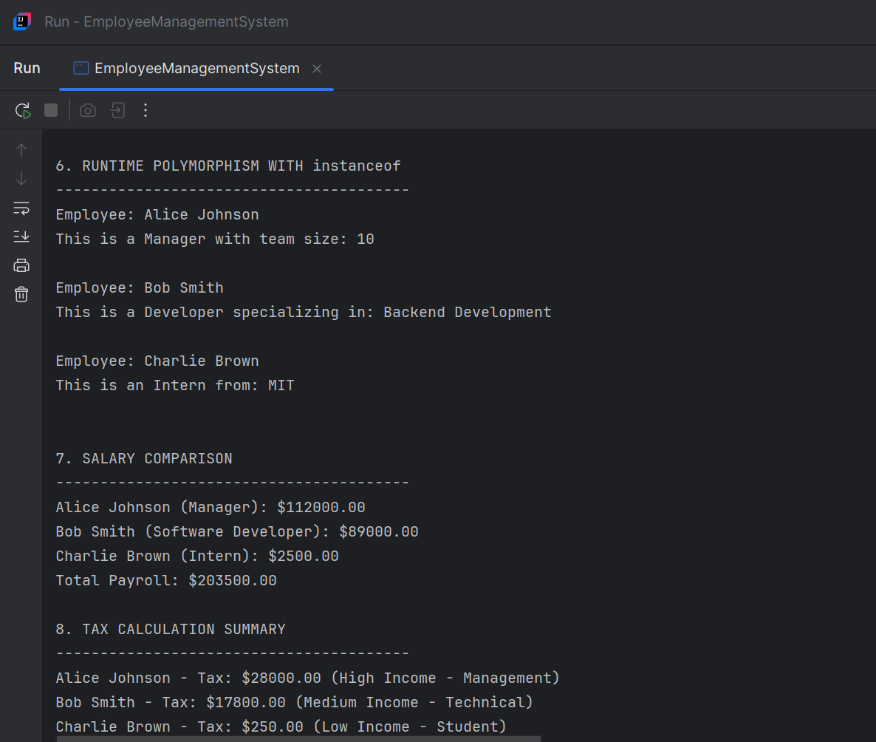

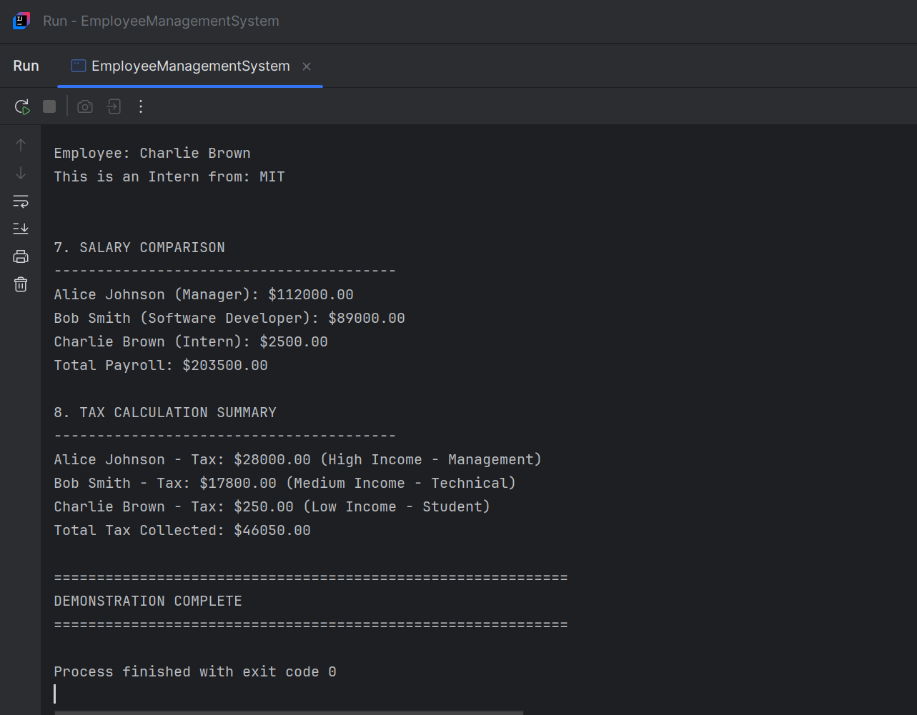

# **TASK 3: String and Exception Handling Task**

**Objective:** Demonstrate inheritance, method overriding, abstract classes, and interfaces through a Student Grading System.

For the proper implementation of this task, one packet structure named com.student.grading and 3 java classes under that package have been created.

JAVA CODE:

File 1: InvalidMarkException.java – Custom Exception Class

package com.student.grading;  
  
*/**  
 * Custom exception for handling invalid mark entries  
 * This exception is thrown when marks are outside the valid range (0-100)  
 * or when marks contain invalid characters  
 */*public class InvalidMarkException extends Exception {  
  
 // Constructor with message  
 public InvalidMarkException(String message) {  
 super(message);  
 }  
  
 // Constructor with message and cause  
 public InvalidMarkException(String message, Throwable cause) {  
 super(message, cause);  
 }  
  
 // Constructor with default message  
 public InvalidMarkException() {  
 super("Invalid mark entered. Marks must be between 0 and 100.");  
 }  
}

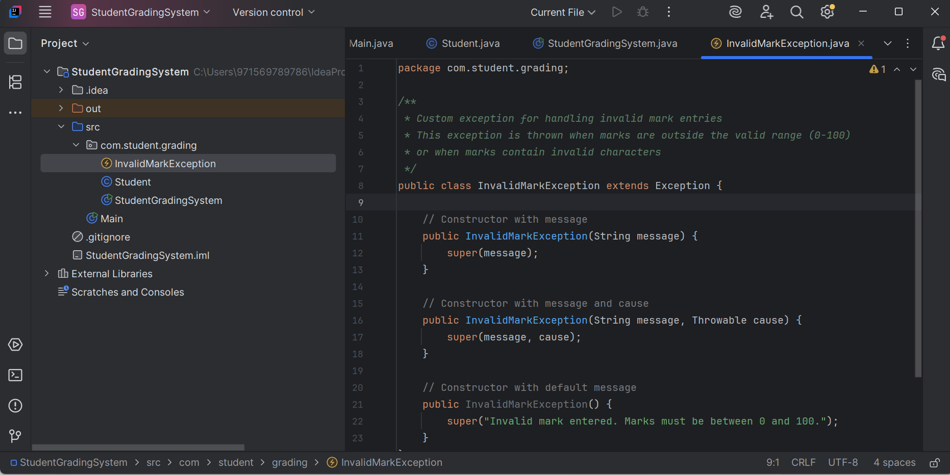

File 2: Student.java – Student Data Class

package com.student.grading;  
  
*/**  
 * Student class to store student information  
 * Demonstrates string manipulation and formatting  
 */*public class Student {  
 private String name;  
 private double marks;  
 private String grade;  
  
 // Constructor  
 public Student(String name, double marks) throws InvalidMarkException {  
 this.setName(name);  
 this.setMarks(marks);  
 this.calculateGrade();  
 }  
  
 // Setter for name with string manipulation  
 public void setName(String name) {  
 if (name == null || name.trim().isEmpty()) {  
 throw new IllegalArgumentException("Name cannot be empty or null");  
 }  
  
 // String manipulation: trim, convert to proper case  
 this.name = formatName(name.trim());  
 }  
  
 // Setter for marks with validation  
 public void setMarks(double marks) throws InvalidMarkException {  
 if (marks < 0 || marks > 100) {  
 throw new InvalidMarkException("Marks must be between 0 and 100. Entered: " + marks);  
 }  
 this.marks = marks;  
 }  
  
 // String method to format name properly  
 private String formatName(String name) {  
 if (name == null || name.isEmpty()) {  
 return "";  
 }  
  
 // Convert to lowercase and capitalize first letter of each word  
 String[] words = name.toLowerCase().split("\\s+");  
 StringBuilder formattedName = new StringBuilder();  
  
 for (String word : words) {  
 if (!word.isEmpty()) {  
 formattedName.append(Character.*toUpperCase*(word.charAt(0)))  
 .append(word.substring(1))  
 .append(" ");  
 }  
 }  
  
 return formattedName.toString().trim();  
 }  
  
 // Calculate grade based on marks  
 private void calculateGrade() {  
 if (marks >= 90) {  
 grade = "A+";  
 } else if (marks >= 80) {  
 grade = "A";  
 } else if (marks >= 70) {  
 grade = "B";  
 } else if (marks >= 60) {  
 grade = "C";  
 } else if (marks >= 50) {  
 grade = "D";  
 } else {  
 grade = "F";  
 }  
 }  
  
 // Getters  
 public String getName() {  
 return name;  
 }  
  
 public double getMarks() {  
 return marks;  
 }  
  
 public String getGrade() {  
 return grade;  
 }  
  
 // String formatting method for display  
 public String getFormattedStudentInfo() {  
 return String.*format*("%-20s | %6.2f | %s", name, marks, grade);  
 }  
  
 // Override toString for custom string representation  
 @Override  
 public String toString() {  
 return String.*format*("Student{name='%s', marks=%.2f, grade='%s'}",  
 name, marks, grade);  
 }  
}

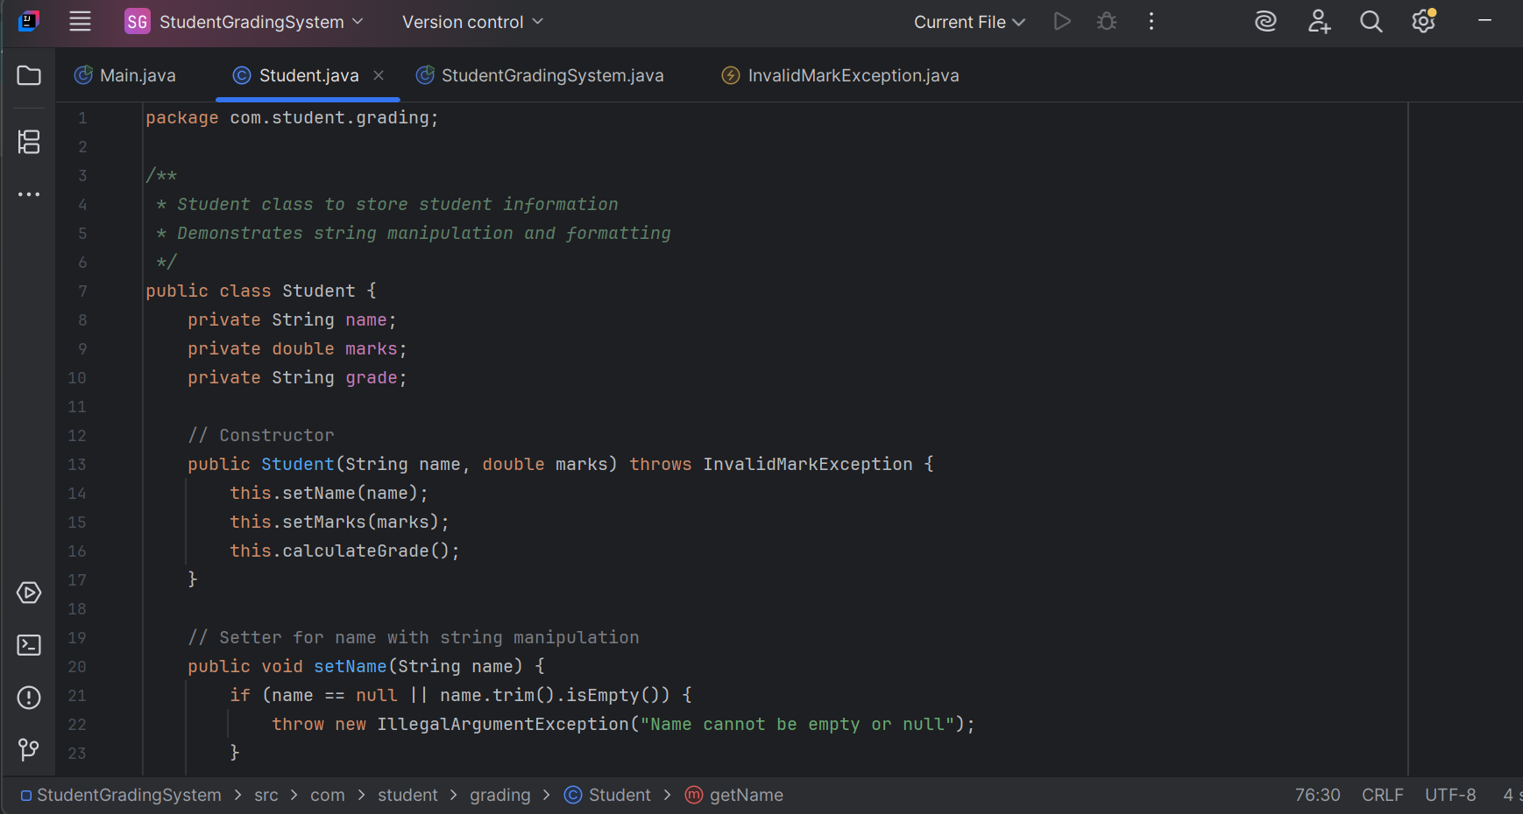

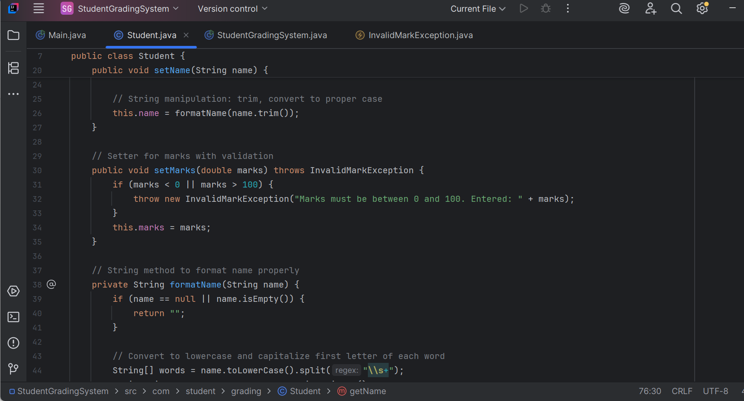

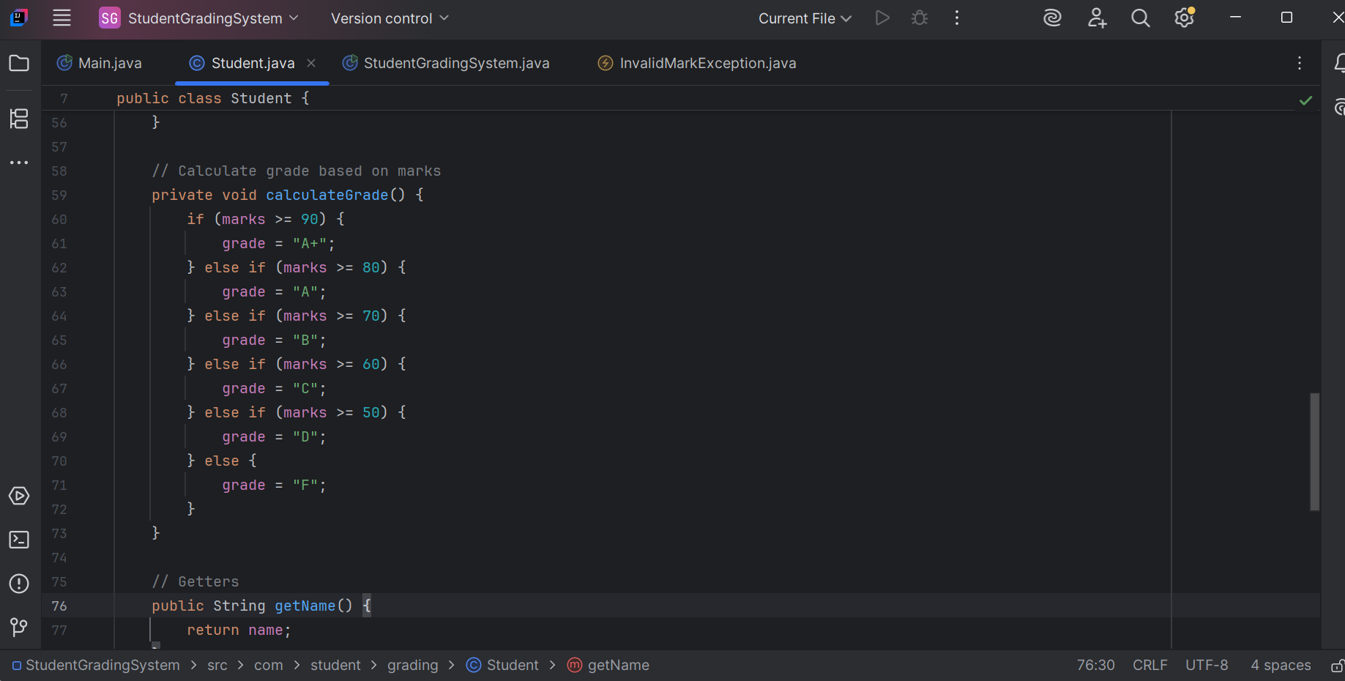

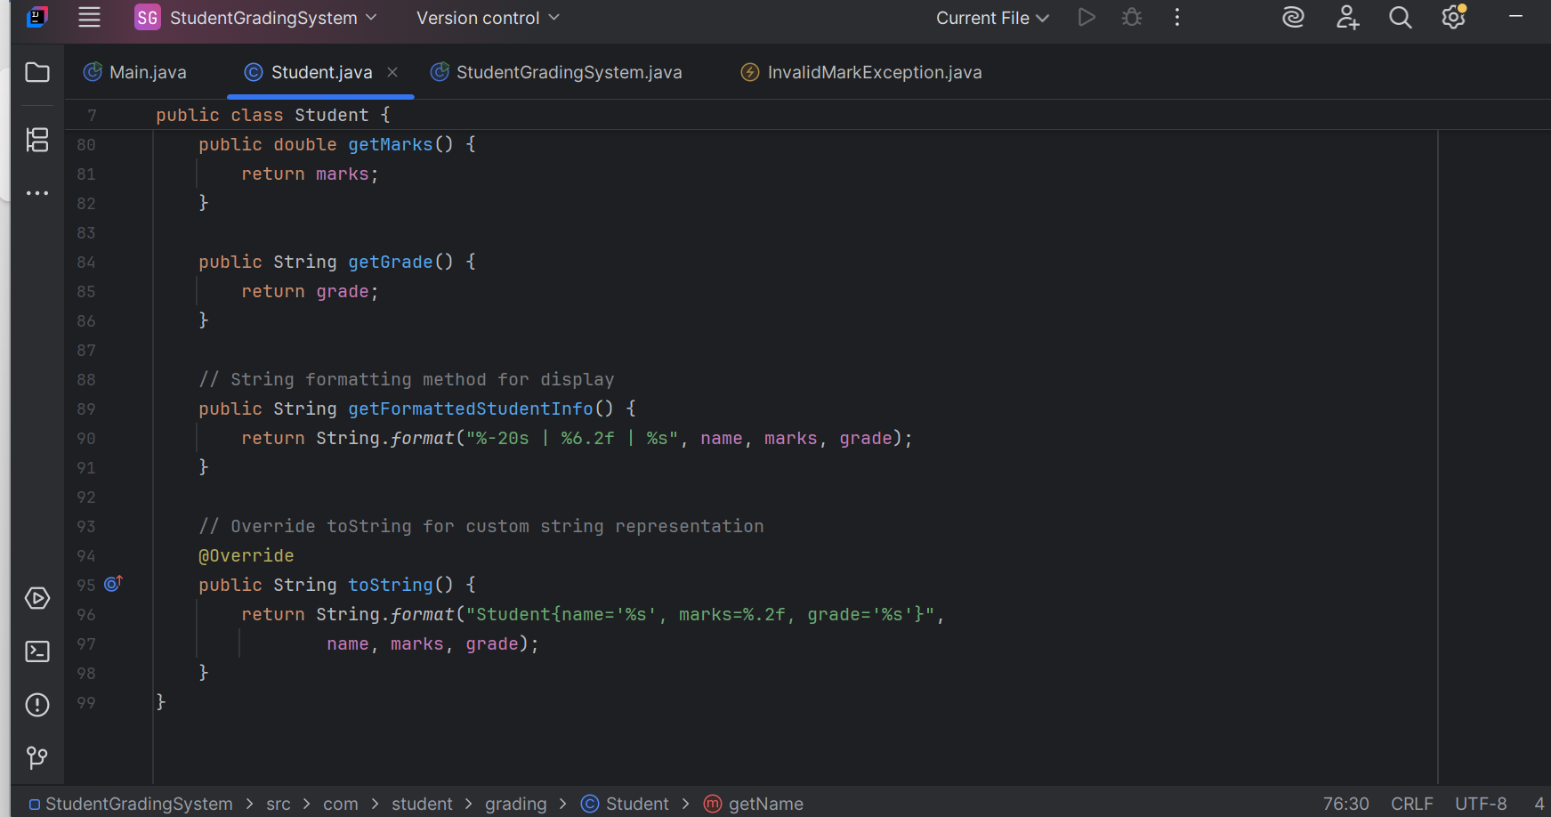

File 3: StudentGradingSystem.java – Main System Class

package com.student.grading;  
  
import java.util.ArrayList;  
import java.util.List;  
import java.util.Scanner;  
*/**  
 * Main Student Grading System class  
 * Demonstrates string manipulation, exception handling, and input validation  
 */*public class StudentGradingSystem {  
 private List<Student> students;  
 private Scanner scanner;  
  
 public StudentGradingSystem() {  
 students = new ArrayList<>();  
 scanner = new Scanner(System.*in*);  
 }  
  
 // Main method to run the program  
 public static void main(String[] args) {  
 StudentGradingSystem system = new StudentGradingSystem();  
 system.run();  
 }  
  
 // Main program loop  
 public void run() {  
 System.*out*.println("=".repeat(60));  
 System.*out*.println(" STUDENT GRADING SYSTEM");  
 System.*out*.println("=".repeat(60));  
  
 while (true) {  
 try {  
 displayMenu();  
 int choice = getValidChoice();  
  
 switch (choice) {  
 case 1:  
 addStudent();  
 break;  
 case 2:  
 displayAllStudents();  
 break;  
 case 3:  
 findStudent();  
 break;  
 case 4:  
 System.*out*.println("Thank you for using Student Grading System!");  
 return;  
 default:  
 System.*out*.println("Invalid choice. Please try again.");  
 }  
 } catch (Exception e) {  
 System.*out*.println("An unexpected error occurred: " + e.getMessage());  
 } finally {  
 System.*out*.println("\nPress Enter to continue...");  
 scanner.nextLine();  
 }  
 }  
 }  
  
 // Display menu options  
 private void displayMenu() {  
 System.*out*.println("\n" + "-".repeat(40));  
 System.*out*.println("1. Add Student");  
 System.*out*.println("2. Display All Students");  
 System.*out*.println("3. Find Student");  
 System.*out*.println("4. Exit");  
 System.*out*.println("-".repeat(40));  
 System.*out*.print("Enter your choice: ");  
 }  
  
 // Get valid menu choice with exception handling  
 private int getValidChoice() {  
 try {  
 String input = scanner.nextLine().trim();  
 return Integer.*parseInt*(input);  
 } catch (NumberFormatException e) {  
 return -1; // Invalid choice  
 }  
 }  
  
 // Add a new student with comprehensive exception handling  
 private void addStudent() {  
 String name = null;  
 double marks = 0;  
 boolean success = false;  
  
 try {  
 // Get student name with string validation  
 System.*out*.print("Enter student name: ");  
 name = scanner.nextLine();  
  
 // Validate name using string methods  
 if (name == null || name.trim().isEmpty()) {  
 throw new IllegalArgumentException("Name cannot be empty");  
 }  
  
 // Check if name contains only valid characters  
 if (!isValidName(name)) {  
 throw new IllegalArgumentException("Name can only contain letters and spaces");  
 }  
  
 // Get marks with validation  
 System.*out*.print("Enter marks (0-100): ");  
 String marksInput = scanner.nextLine().trim();  
  
 // Validate marks input  
 marks = parseMarks(marksInput);  
  
 // Create student object  
 Student student = new Student(name, marks);  
 students.add(student);  
  
 success = true;  
 System.*out*.println("\n✓ Student added successfully!");  
 System.*out*.println("Student Details: " + student.getFormattedStudentInfo());  
  
 } catch (InvalidMarkException e) {  
 System.*out*.println("✗ Invalid Marks Error: " + e.getMessage());  
 } catch (IllegalArgumentException e) {  
 System.*out*.println("✗ Input Error: " + e.getMessage());  
 } catch (Exception e) {  
 System.*out*.println("✗ Unexpected error: " + e.getMessage());  
 } finally {  
 // Finally block always executes  
 if (success) {  
 System.*out*.println("Total students in system: " + students.size());  
 } else {  
 System.*out*.println("Failed to add student. Please try again.");  
 }  
 }  
 }  
  
 // Validate name using string methods  
 private boolean isValidName(String name) {  
 if (name == null || name.trim().isEmpty()) {  
 return false;  
 }  
  
 // Check if name contains only letters and spaces  
 return name.trim().matches("[a-zA-Z\\s]+");  
 }  
  
 // Parse marks string with validation  
 private double parseMarks(String marksInput) throws InvalidMarkException {  
 if (marksInput == null || marksInput.trim().isEmpty()) {  
 throw new InvalidMarkException("Marks cannot be empty");  
 }  
  
 try {  
 double marks = Double.*parseDouble*(marksInput);  
 if (marks < 0 || marks > 100) {  
 throw new InvalidMarkException("Marks must be between 0 and 100");  
 }  
 return marks;  
 } catch (NumberFormatException e) {  
 throw new InvalidMarkException("Invalid marks format: " + marksInput, e);  
 }  
 }  
  
 // Display all students with formatted output  
 private void displayAllStudents() {  
 if (students.isEmpty()) {  
 System.*out*.println("No students in the system.");  
 return;  
 }  
  
 System.*out*.println("\n" + "=".repeat(60));  
 System.*out*.println(" STUDENT RECORDS");  
 System.*out*.println("=".repeat(60));  
 System.*out*.printf("%-20s | %s | %s%n", "Name", "Marks", "Grade");  
 System.*out*.println("-".repeat(60));  
  
 for (Student student : students) {  
 System.*out*.println(student.getFormattedStudentInfo());  
 }  
  
 System.*out*.println("-".repeat(60));  
 System.*out*.println("Total Students: " + students.size());  
  
 // Calculate and display statistics  
 displayStatistics();  
 }  
  
 // Display statistics  
 private void displayStatistics() {  
 if (students.isEmpty()) return;  
  
 double total = 0;  
 double highest = students.get(0).getMarks();  
 double lowest = students.get(0).getMarks();  
  
 for (Student student : students) {  
 double marks = student.getMarks();  
 total += marks;  
 highest = Math.*max*(highest, marks);  
 lowest = Math.*min*(lowest, marks);  
 }  
  
 double average = total / students.size();  
  
 System.*out*.println("\nStatistics:");  
 System.*out*.printf("Average Marks: %.2f%n", average);  
 System.*out*.printf("Highest Marks: %.2f%n", highest);  
 System.*out*.printf("Lowest Marks: %.2f%n", lowest);  
 }  
  
 // Find student by name  
 private void findStudent() {  
 if (students.isEmpty()) {  
 System.*out*.println("No students in the system.");  
 return;  
 }  
  
 try {  
 System.*out*.print("Enter student name to search: ");  
 String searchName = scanner.nextLine().trim();  
  
 if (searchName.isEmpty()) {  
 System.*out*.println("Search name cannot be empty.");  
 return;  
 }  
  
 Student foundStudent = null;  
  
 // Search using string methods (case-insensitive)  
 for (Student student : students) {  
 if (student.getName().toLowerCase().contains(searchName.toLowerCase())) {  
 foundStudent = student;  
 break;  
 }  
 }  
  
 if (foundStudent != null) {  
 System.*out*.println("\n✓ Student Found:");  
 System.*out*.println("-".repeat(40));  
 System.*out*.printf("Name: %s%n", foundStudent.getName());  
 System.*out*.printf("Marks: %.2f%n", foundStudent.getMarks());  
 System.*out*.printf("Grade: %s%n", foundStudent.getGrade());  
 System.*out*.println("-".repeat(40));  
 } else {  
 System.*out*.println("✗ Student not found: " + searchName);  
 }  
  
 } catch (Exception e) {  
 System.*out*.println("Error during search: " + e.getMessage());  
 } finally {  
 System.*out*.println("Search operation completed.");  
 }  
 }  
}

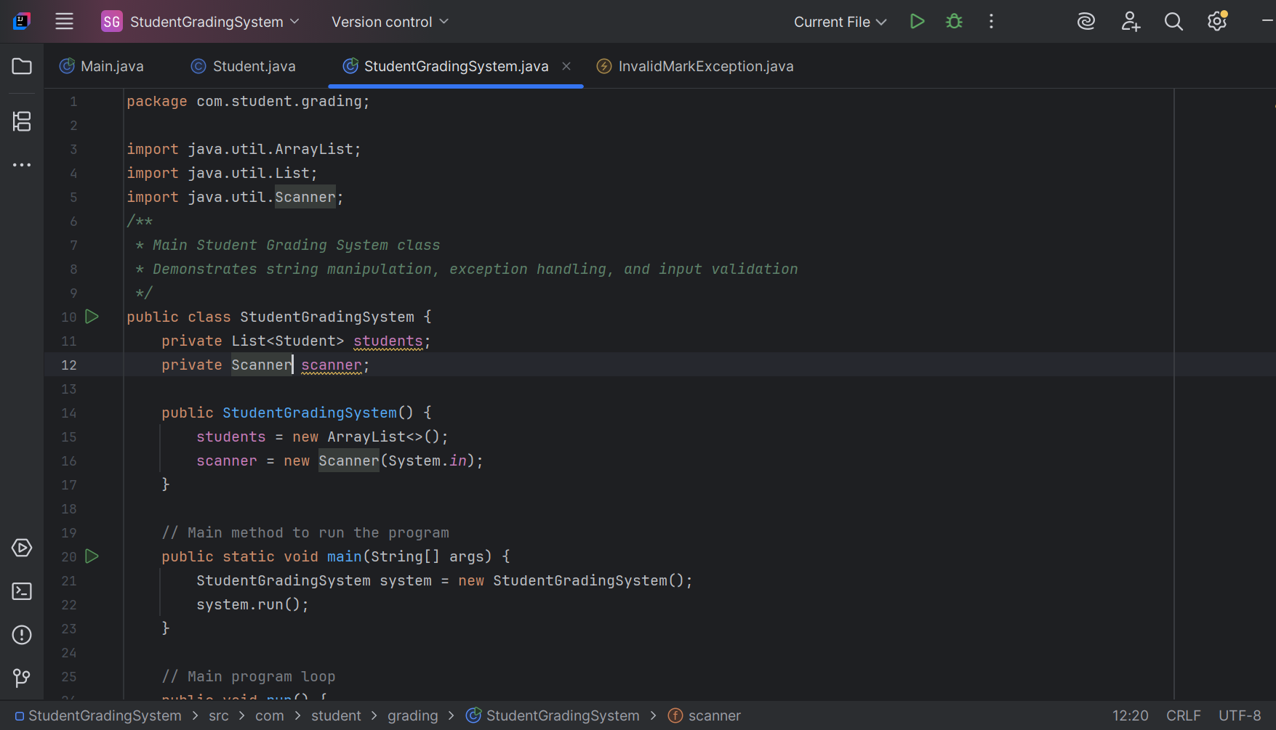

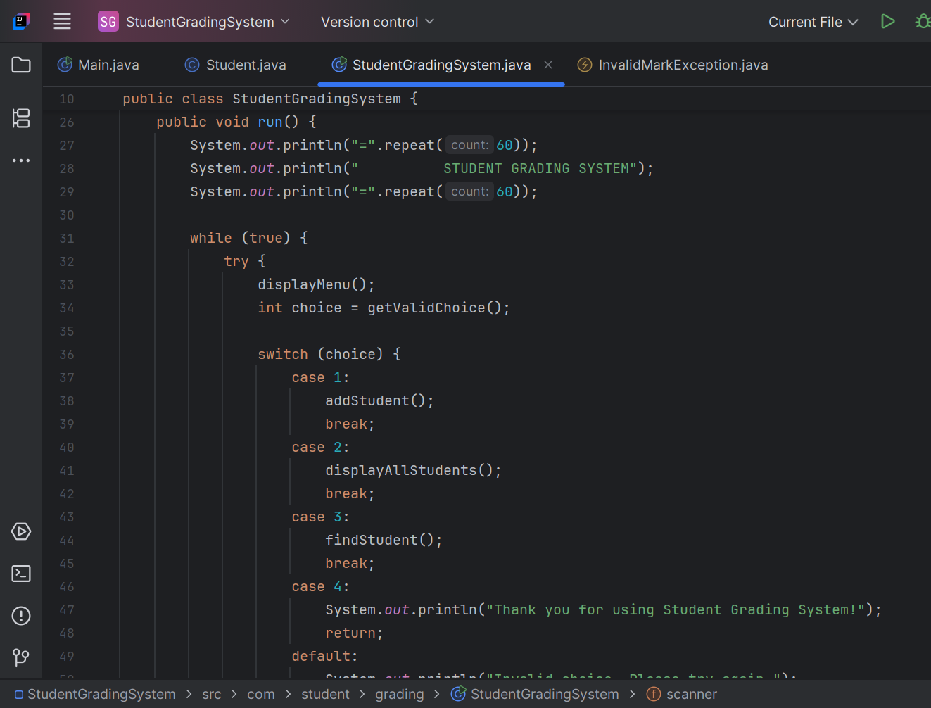

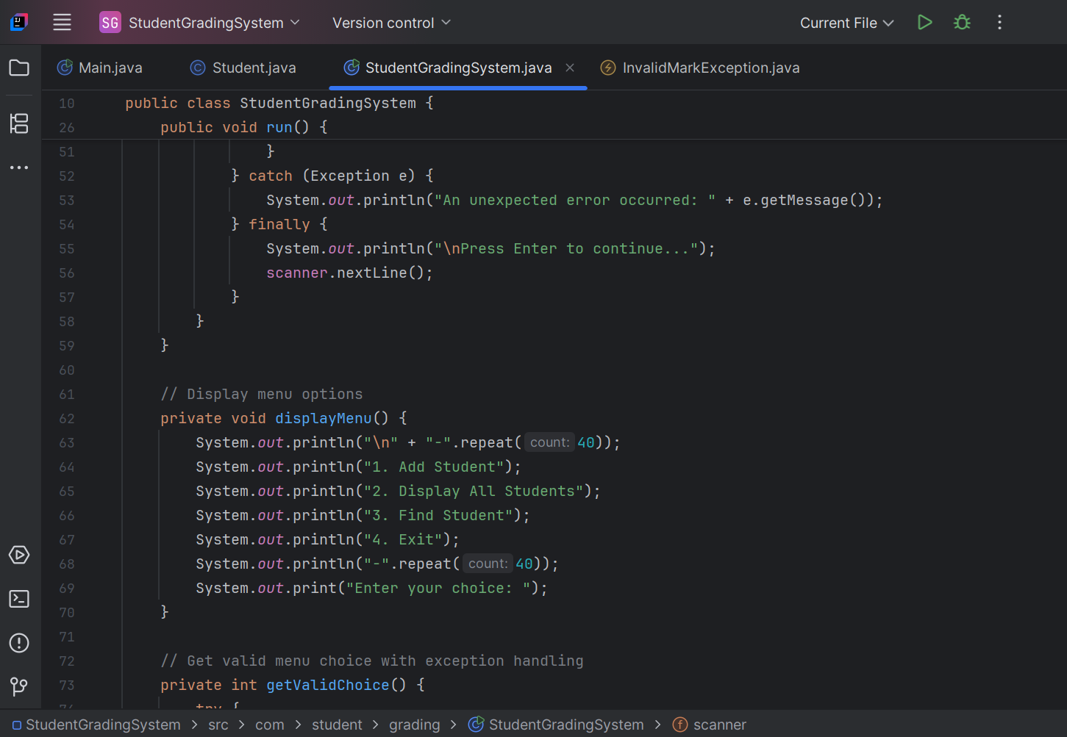

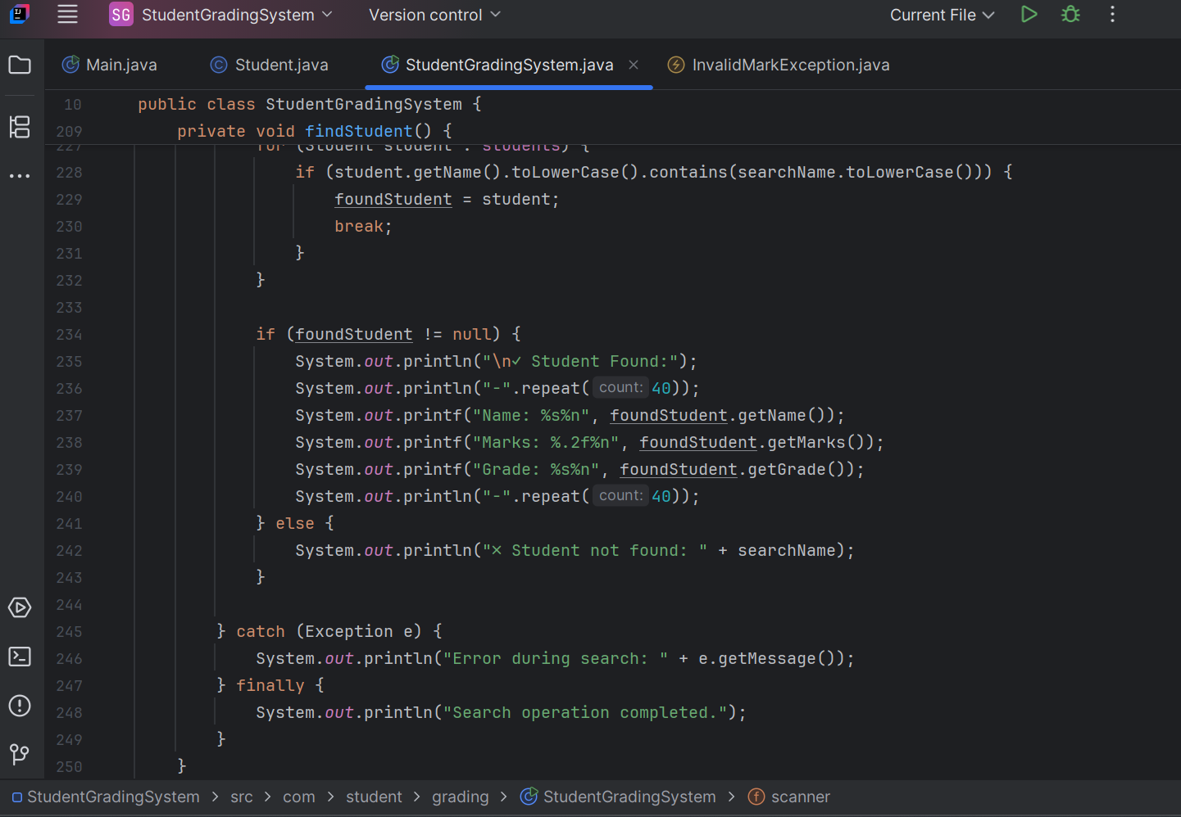

**Key features implemented in this StudentGradingSystem project**

* 1. **String Manipulation:**
* Name formatting: Converts names to proper case
* String validation: Checks for empty/null strings and valid characters
* String formatting: Uses String.format() for aligned output
* String methods: trim() , toLowerCase() , split() , contains() , matches()
  1. **Exception Handling:**
* Custom Exception: InvalidMarkException for mark validation
* Try-catch-finally: Comprehensive error handling in all input methods
* Multiple exception types: Handles NumberFormatException, IllegalArgumentException
* Graceful error recovery: Program continues running after exceptions
  1. **Custom Exception Implementation:**
* Multiple constructors: Default, with message, and with cause
* Specific error messages: Clear indication of what went wrong
* Proper inheritance: Extends Exception class correctly
  1. **Input Validation:**
* Name validation: Checks for empty names and are invalid characters
* Marks validation: Ensures marks are between 0-100
* Type validation: Handles string-to-number conversion errors

## **OUTPUT SNIPPET**

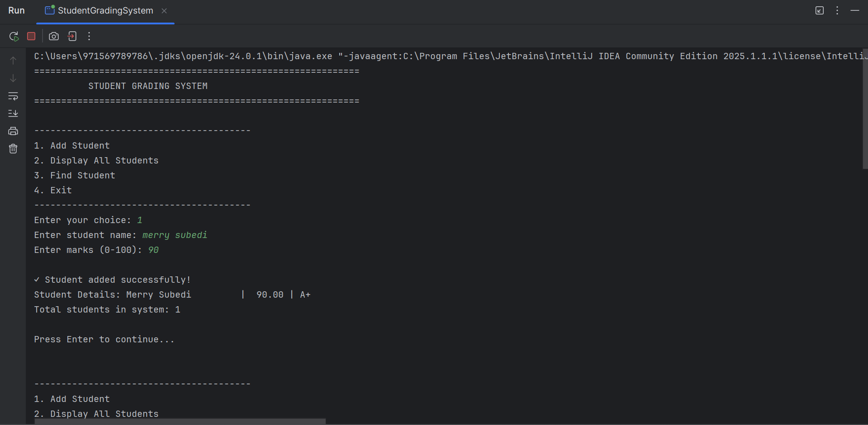

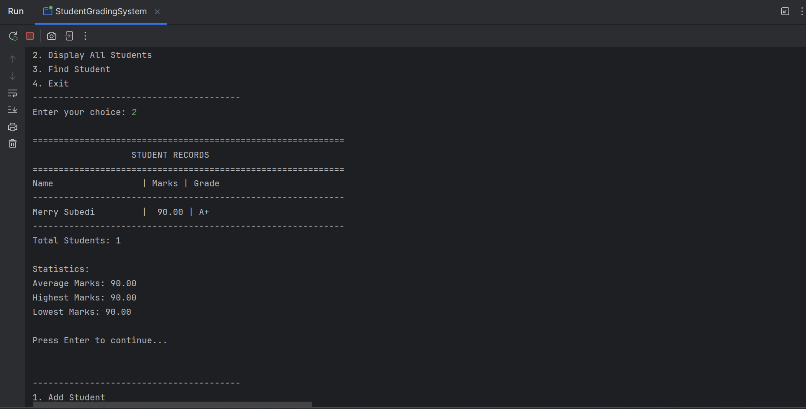

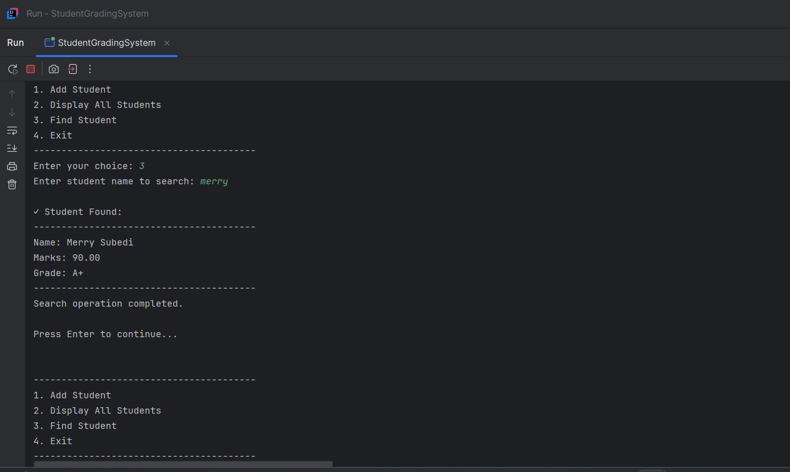

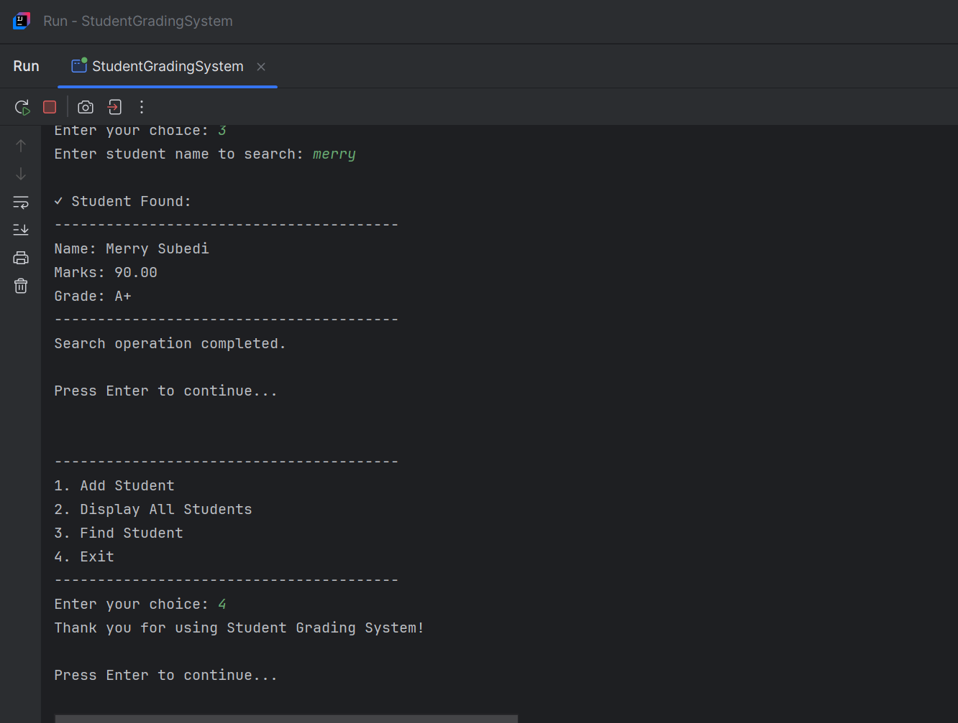

# 

# **TASK 4: Java Collection Tasks**

**Objective:** The main aim of this task is to utilize different java classes effectively.

**JAVA CODE:**

**File: LibraryManagementSystem.java**

import java.util.*;

// Book class to represent book details

class Book {

private String isbn;

private String title;

private String author;

private String genre;

private int publicationYear;

public Book(String isbn, String title, String author, String genre, int publicationYear) {

this.isbn = isbn;

this.title = title;

this.author = author;

this.genre = genre;

this.publicationYear = publicationYear;

}

// Getters

public String getIsbn() { return isbn; }

public String getTitle() { return title; }

public String getAuthor() { return author; }

public String getGenre() { return genre; }

public int getPublicationYear() { return publicationYear; }

@Override

public String toString() {

return String.format("Book{ISBN='%s', Title='%s', Author='%s', Genre='%s', Year=%d}",

isbn, title, author, genre, publicationYear);

}

@Override

public boolean equals(Object obj) {

if (this == obj) return true;

if (obj == null || getClass() != obj.getClass()) return false;

Book book = (Book) obj;

return Objects.equals(isbn, book.isbn);

}

@Override

public int hashCode() {

return Objects.hash(isbn);

}

}

// Member class to represent library members

class Member {

private String memberId;

private String name;

private String email;

public Member(String memberId, String name, String email) {

this.memberId = memberId;

this.name = name;

this.email = email;

}

public String getMemberId() { return memberId; }

public String getName() { return name; }

public String getEmail() { return email; }

@Override

public String toString() {

return String.format("Member{ID='%s', Name='%s', Email='%s'}", memberId, name, email);

}

}

// Main Library Management System class

public class LibraryManagementSystem {

// ArrayList to store all books in the library

private List<Book> libraryBooks;

// HashSet to maintain currently borrowed books (no duplicates)

private Set<Book> borrowedBooks;

// Map to assign each member ID to a list of borrowed books

private Map<String, List<Book>> memberBorrowedBooks;

// List to store library members

private List<Member> members;

public LibraryManagementSystem() {

libraryBooks = new ArrayList<>();

borrowedBooks = new HashSet<>();

memberBorrowedBooks = new HashMap<>();

members = new ArrayList<>();

}

// Add a book to the library

public void addBook(Book book) {

libraryBooks.add(book);

System.out.println("Book added: " + book.getTitle());

}

// Add a member to the library

public void addMember(Member member) {

members.add(member);

memberBorrowedBooks.put(member.getMemberId(), new ArrayList<>());

System.out.println("Member added: " + member.getName());

}

// Borrow a book

public boolean borrowBook(String memberId, String isbn) {

// Find the book

Book bookToBorrow = null;

for (Book book : libraryBooks) {

if (book.getIsbn().equals(isbn)) {

bookToBorrow = book;

break;

}

}

if (bookToBorrow == null) {

System.out.println("Book not found!");

return false;

}

if (borrowedBooks.contains(bookToBorrow)) {

System.out.println("Book is already borrowed!");

return false;

}

if (!memberBorrowedBooks.containsKey(memberId)) {

System.out.println("Member not found!");

return false;

}

// Add to borrowed books set

borrowedBooks.add(bookToBorrow);

// Add to member's borrowed books list

memberBorrowedBooks.get(memberId).add(bookToBorrow);

System.out.println("Book borrowed successfully: " + bookToBorrow.getTitle());

return true;

}

// Return a book

public boolean returnBook(String memberId, String isbn) {

List<Book> memberBooks = memberBorrowedBooks.get(memberId);

if (memberBooks == null) {

System.out.println("Member not found!");

return false;

}

Book bookToReturn = null;

for (Book book : memberBooks) {

if (book.getIsbn().equals(isbn)) {

bookToReturn = book;

break;

}

}

if (bookToReturn == null) {

System.out.println("Book not found in member's borrowed list!");

return false;

}

// Remove from borrowed books set

borrowedBooks.remove(bookToReturn);

// Remove from member's borrowed books list

memberBooks.remove(bookToReturn);

System.out.println("Book returned successfully: " + bookToReturn.getTitle());

return true;

}

// Display all books using enhanced for loop

public void displayAllBooks() {

System.out.println("\n=== All Library Books (Enhanced For Loop) ===");

if (libraryBooks.isEmpty()) {

System.out.println("No books in the library.");

return;

}

for (Book book : libraryBooks) {

System.out.println(book);

}

}

// Display borrowed books using Iterator

public void displayBorrowedBooks() {

System.out.println("\n=== Currently Borrowed Books (Iterator) ===");

if (borrowedBooks.isEmpty()) {

System.out.println("No books are currently borrowed.");

return;

}

Iterator<Book> iterator = borrowedBooks.iterator();

while (iterator.hasNext()) {

Book book = iterator.next();

System.out.println(book);

}

}

// Display member borrowed books using enhanced for loop

public void displayMemberBorrowedBooks() {

System.out.println("\n=== Books Borrowed by Members ===");

for (Map.Entry<String, List<Book>> entry : memberBorrowedBooks.entrySet()) {

String memberId = entry.getKey();

List<Book> books = entry.getValue();

System.out.println("Member ID: " + memberId);

if (books.isEmpty()) {

System.out.println(" No books borrowed");

} else {

for (Book book : books) {

System.out.println(" " + book);

}

}

}

}

// Demonstrate wildcard usage - method that accepts any list of books

public void displayBooksWildcard(List<? extends Book> books) {

System.out.println("\n=== Books Display (Wildcard Method) ===");

for (Book book : books) {

System.out.println(book);

}

}

// Method using wildcards for searching

public List<Book> searchBooksByGenre(String genre) {

List<Book> result = new ArrayList<>();

for (Book book : libraryBooks) {

if (book.getGenre().equalsIgnoreCase(genre)) {

result.add(book);

}

}

return result;

}

// Generic method to display any collection

public <T> void displayCollection(Collection<T> collection, String title) {

System.out.println("\n=== " + title + " ===");

for (T item : collection) {

System.out.println(item);

}

}

// Get available books (not borrowed)

public List<Book> getAvailableBooks() {

List<Book> availableBooks = new ArrayList<>();

for (Book book : libraryBooks) {

if (!borrowedBooks.contains(book)) {

availableBooks.add(book);

}

}

return availableBooks;

}

// Get member by ID

public Member getMemberById(String memberId) {

for (Member member : members) {

if (member.getMemberId().equals(memberId)) {

return member;

}

}

return null;

}

// Main method to demonstrate the system

public static void main(String[] args) {

LibraryManagementSystem library = new LibraryManagementSystem();

// Add books to the library

library.addBook(new Book("978-0134685991", "Effective Java", "Joshua Bloch", "Programming", 2017));

library.addBook(new Book("978-0596009205", "Head First Design Patterns", "Eric Freeman", "Programming", 2004));

library.addBook(new Book("978-0321356680", "Effective C++", "Scott Meyers", "Programming", 2005));

library.addBook(new Book("978-0132350884", "Clean Code", "Robert Martin", "Programming", 2008));

library.addBook(new Book("978-1617291999", "Java 8 in Action", "Raoul-Gabriel Urma", "Programming", 2014));

// Add members

library.addMember(new Member("M001", "Alice Johnson", "alice@email.com"));

library.addMember(new Member("M002", "Bob Smith", "bob@email.com"));

library.addMember(new Member("M003", "Carol Davis", "carol@email.com"));

// Display all books

library.displayAllBooks();

// Borrow some books

System.out.println("\n=== Borrowing Books ===");

library.borrowBook("M001", "978-0134685991");

library.borrowBook("M001", "978-0596009205");

library.borrowBook("M002", "978-0321356680");

library.borrowBook("M003", "978-0132350884");

// Display borrowed books

library.displayBorrowedBooks();

// Display member borrowed books

library.displayMemberBorrowedBooks();

// Demonstrate wildcard usage

List<Book> programmingBooks = library.searchBooksByGenre("Programming");

library.displayBooksWildcard(programmingBooks);

// Demonstrate generic method

library.displayCollection(library.getAvailableBooks(), "Available Books");

library.displayCollection(library.members, "Library Members");

// Return a book

System.out.println("\n=== Returning Books ===");

library.returnBook("M001", "978-0134685991");

// Display updated borrowed books

library.displayBorrowedBooks();

// Display updated member borrowed books

library.displayMemberBorrowedBooks();

// Try to borrow the same book again

System.out.println("\n=== Testing Duplicate Borrowing ===");

library.borrowBook("M002", "978-0321356680"); // Should fail

// Final display of available books

library.displayCollection(library.getAvailableBooks(), "Final Available Books");

}

}

**CODE SNIPPET:**

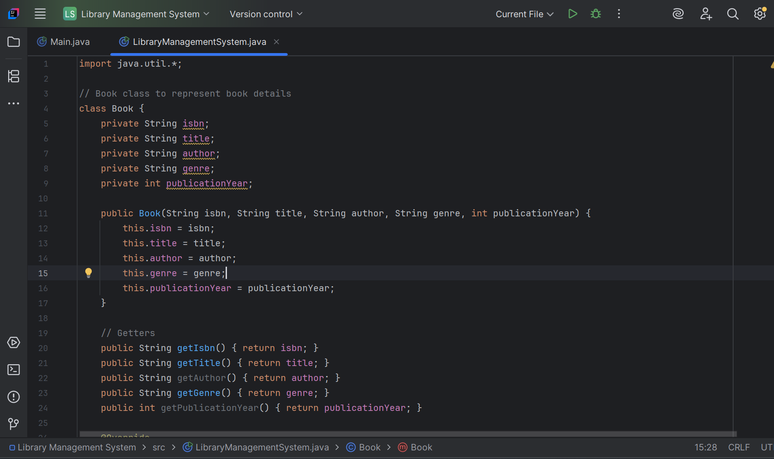

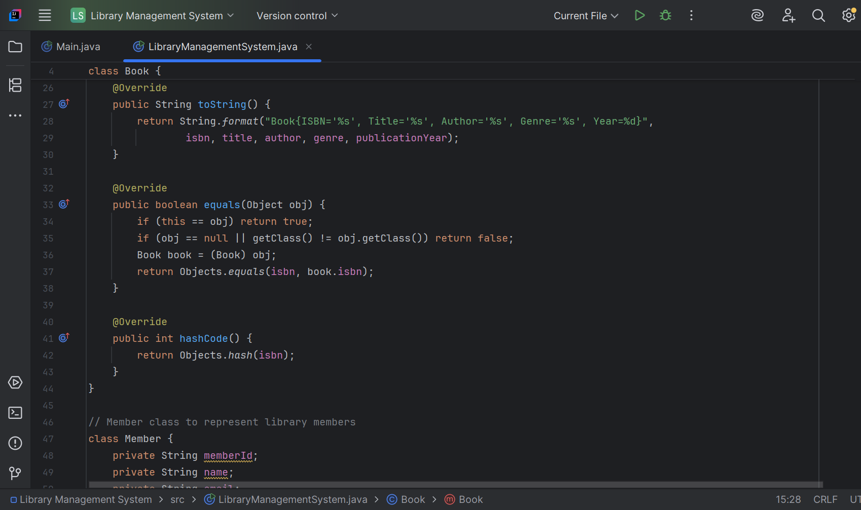

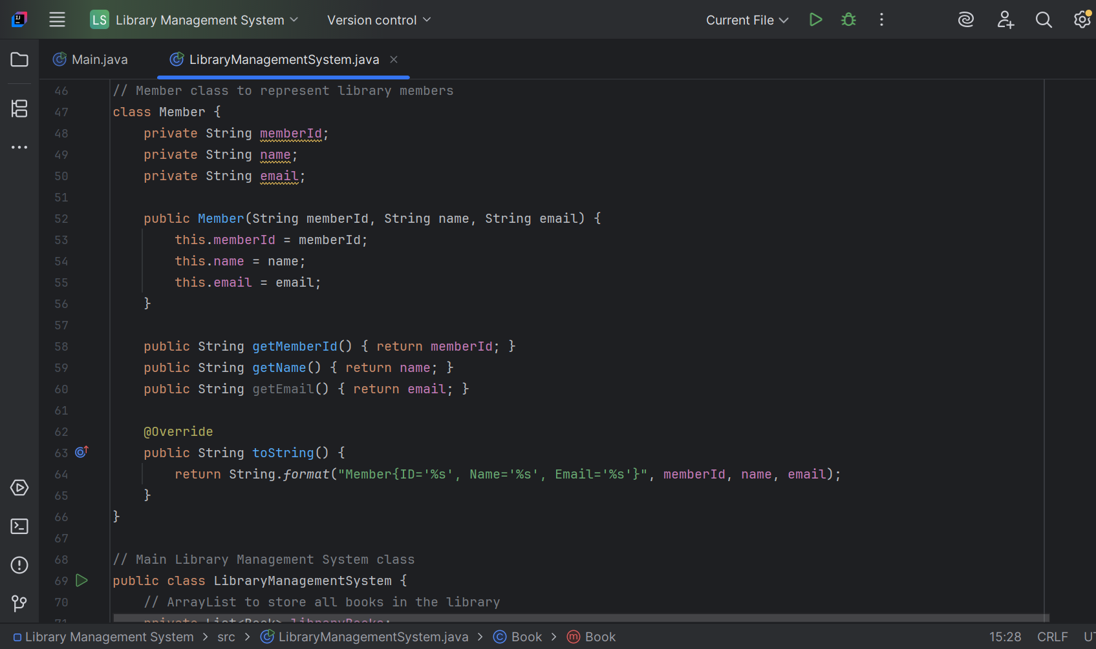

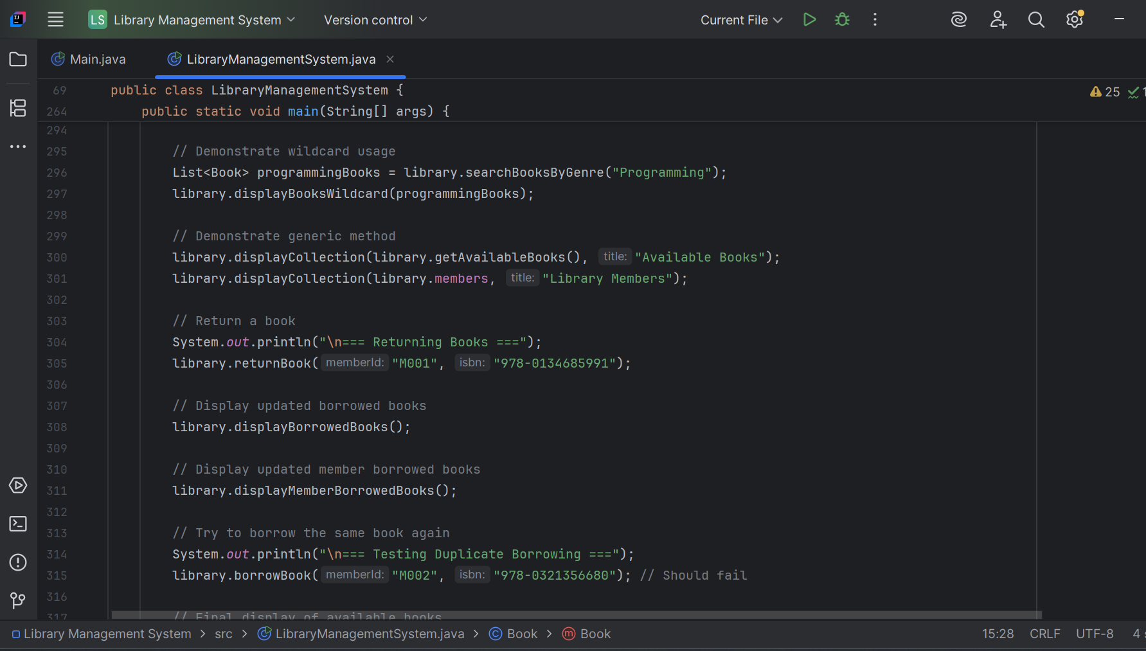

**System Functionality:**

1. **Book Management:** Add books, track availability
2. **Member Management:** Add members, track their borrowed books
3. **Borrowing System:** Borrow/return books with validation
4. **Display Methods:** Multiple ways to view library data
5. **Search Functionality:** Find books by genre using wildcards.

**Demonstration of Requirements:**

* **List Operations:** Adding, searching, iterating through books and members
* **Set Operations:** Preventing duplicate borrowed books, efficient lookups
* **Map Operations:** Associating member IDs with borrowed book lists
* **Type Safety:** No raw types used, all collections are properly parameterized
* **Wildcards:** Upper bounded wildcards and generic methods

## **OUTPUT SNIPPET**

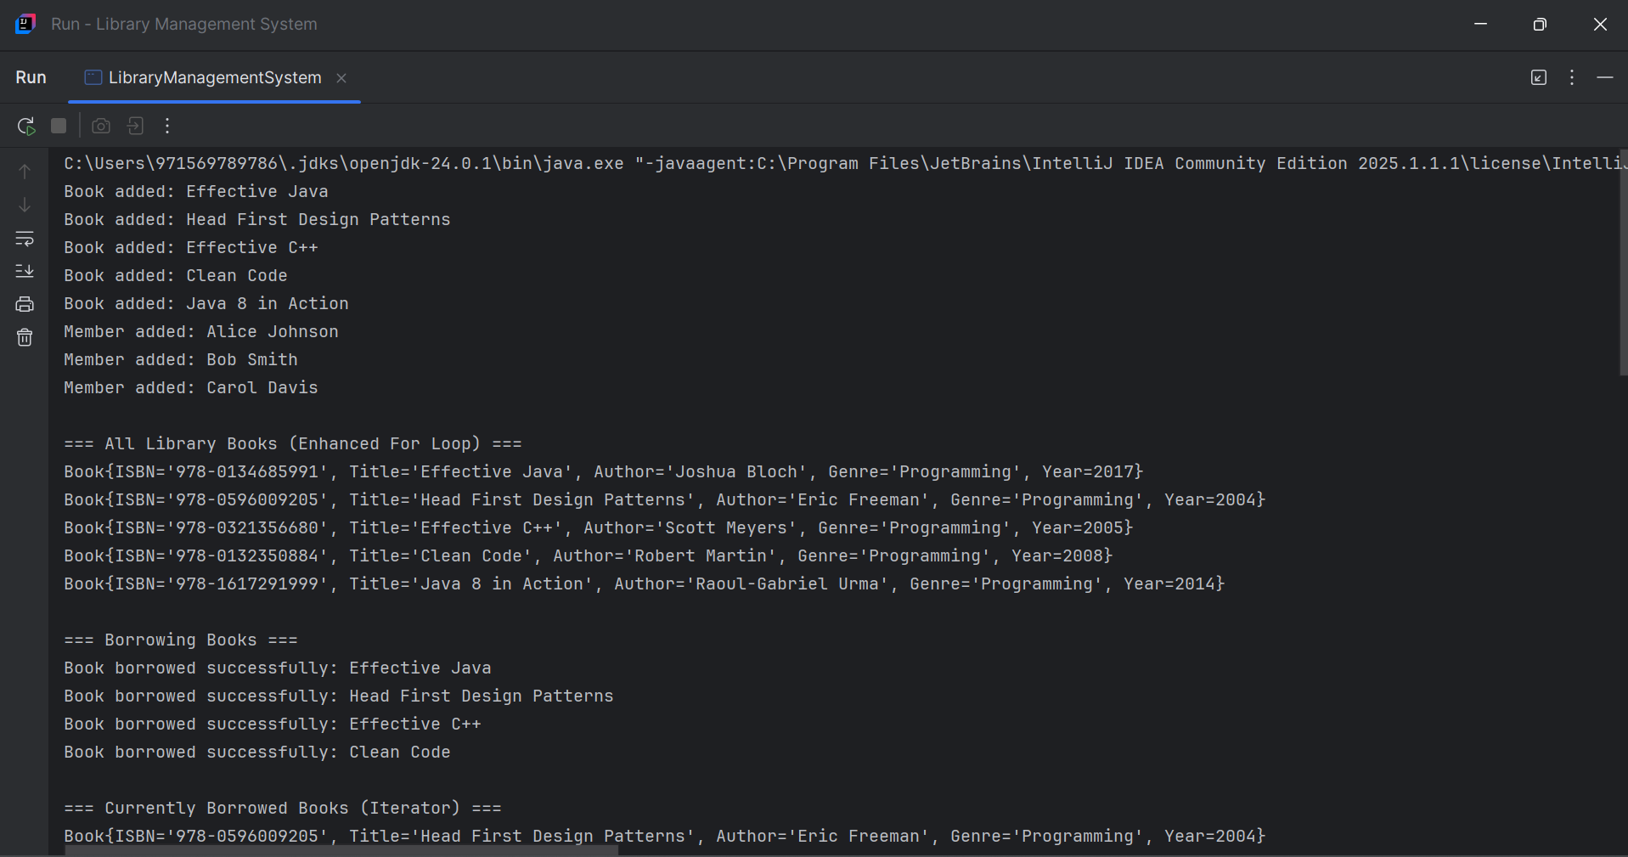

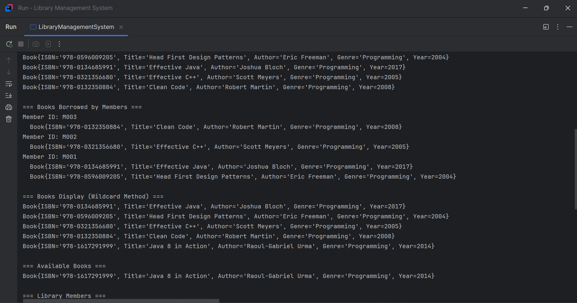

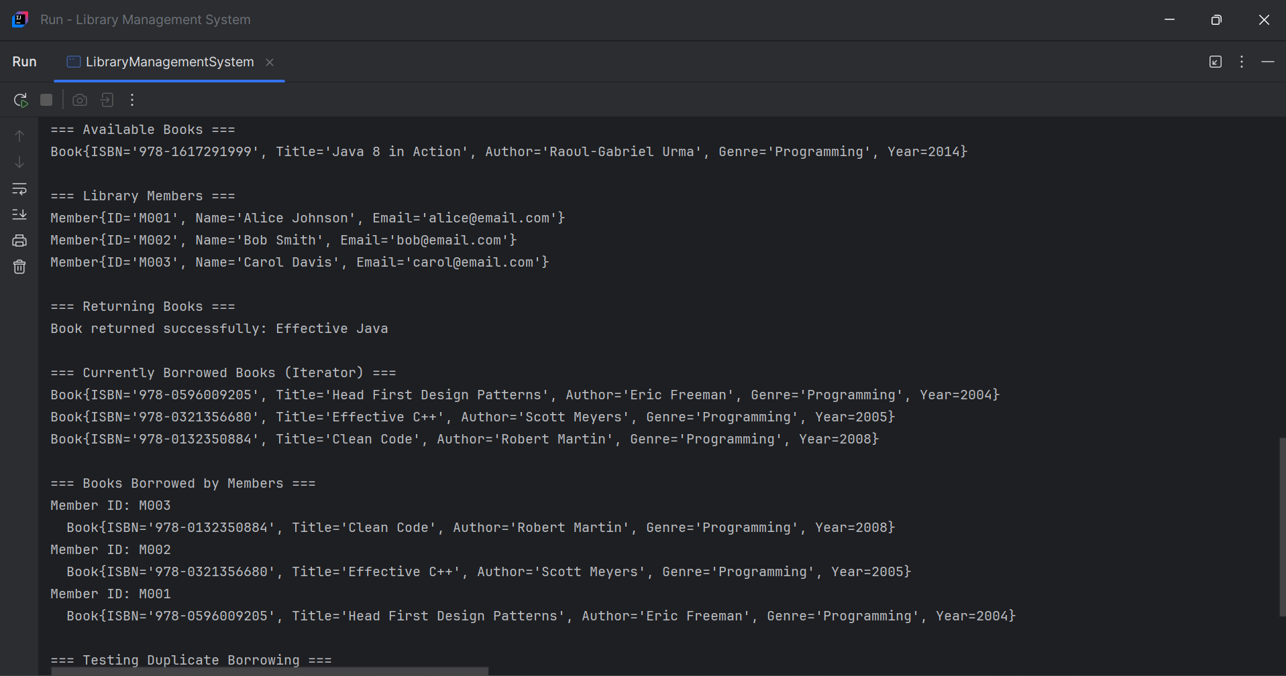

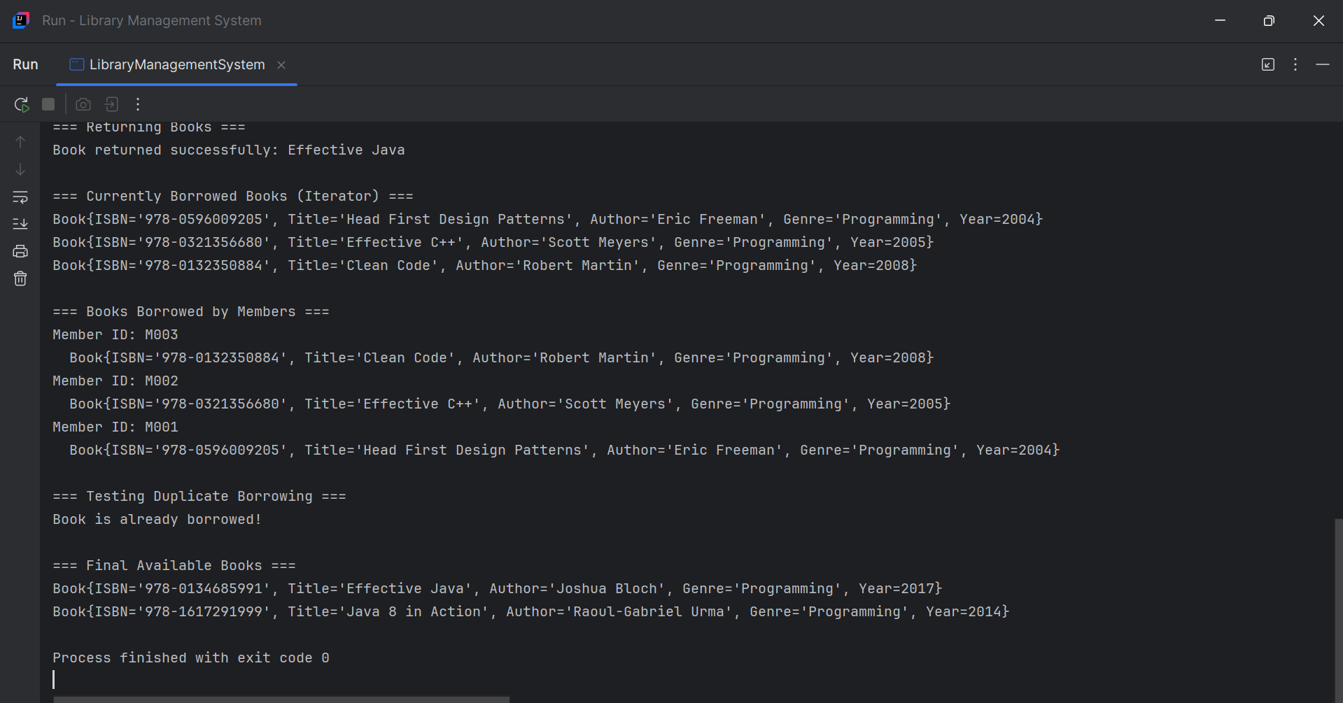

# **TASK 5: Case Study- Design Patterns in Real Project**

## **Case Study: Applying Design Patterns in an Online Food Delivery App**

**Executive Summary**

This case study examines the implementation of three essential design patterns in a real-world online food delivery application: Singleton Pattern for database connectivity, Factory Pattern for user role management, and Observer Pattern for order tracking. Each pattern addresses specific architectural challenges while providing scalable and maintainable solutions.

1. **Singleton Pattern- Database Connection Management**

**Problem Statement**

Ensure a single shared instance of the database connection cross the application.

**Implementation**

***Java Code:***

**Class: DatabaseConnection.java**

public class DatabaseConnection {  
 private static DatabaseConnection *instance*;  
  
 private DatabaseConnection() {  
 System.*out*.println("Connected to the Database.");  
 }  
  
 public static synchronized DatabaseConnection getInstance() {  
 if (*instance* == null) {  
 *instance* = new DatabaseConnection();  
 }  
 return *instance*;  
 }  
  
 public void query(String sql) {  
 System.*out*.println("Executing: " + sql);  
 }  
}

**CODE SNIPPET:**

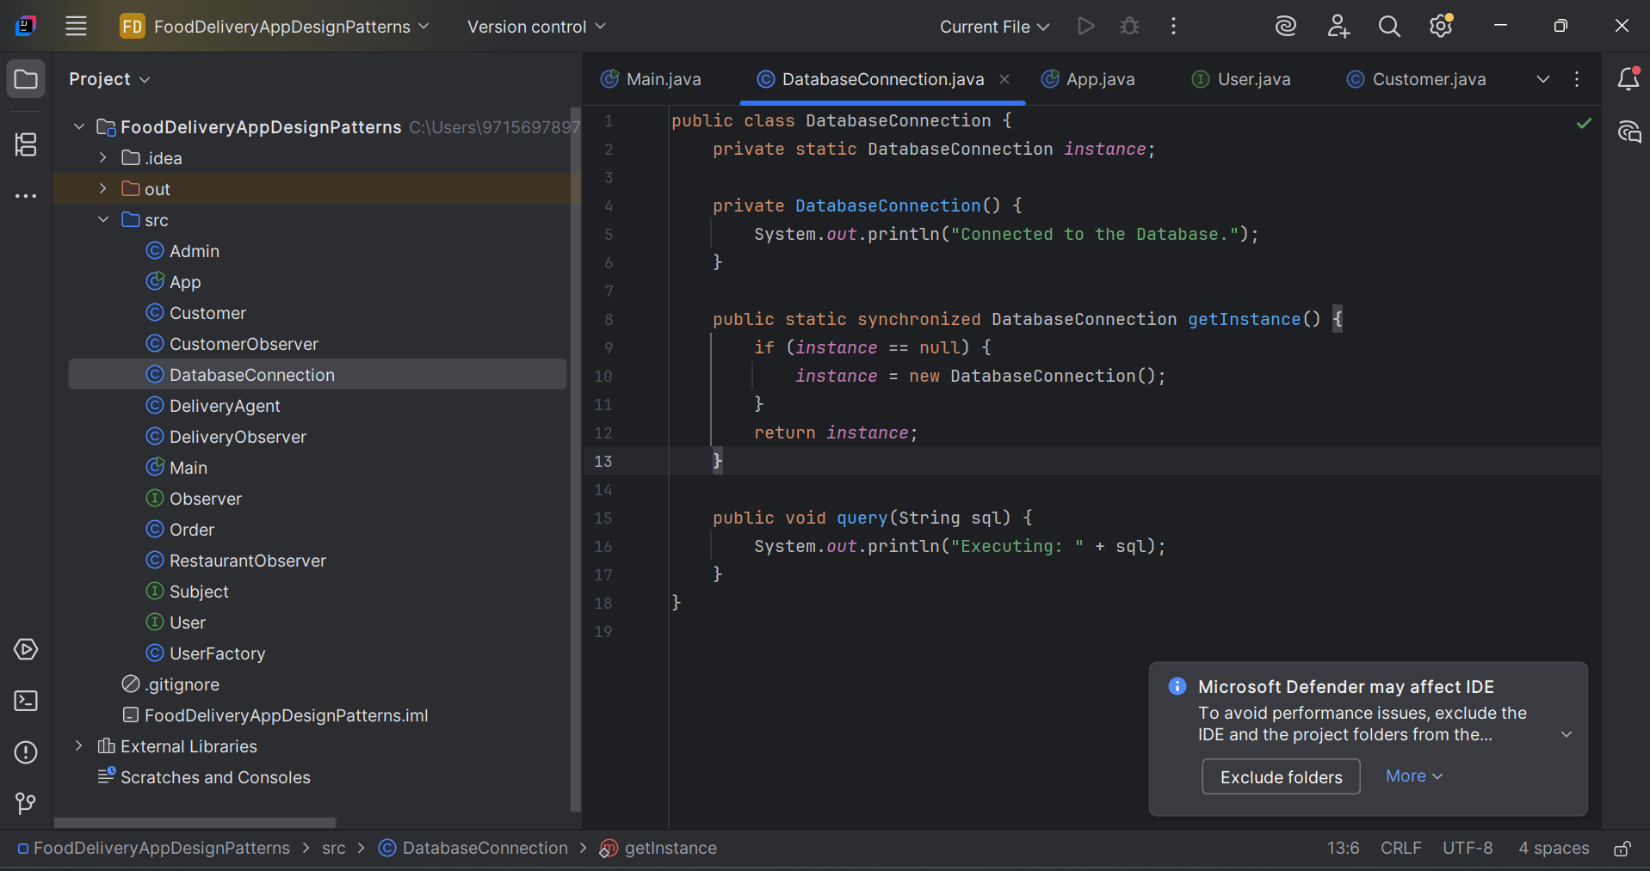

**Class: App.java (Test Code)**

public class App {  
 public static void main(String[] args) {  
 DatabaseConnection db1 = DatabaseConnection.*getInstance*();  
 DatabaseConnection db2 = DatabaseConnection.*getInstance*();  
 db1.query("SELECT * FROM orders");  
  
 System.*out*.println(db1 == db2); // should print true  
 }  
}

**CODE SNIPPET:**

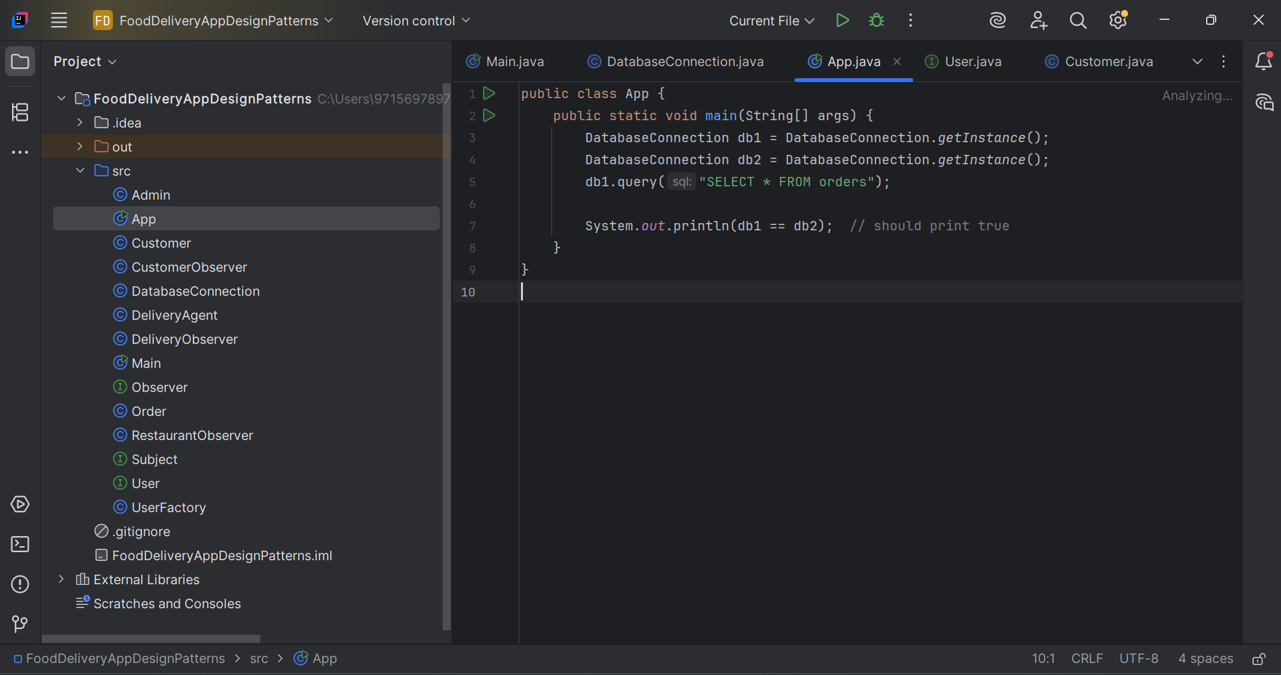

**CLASS DIAGRAM:**

**DatabaseConnection**

**- Instance: Static**

**- DatabaseConnection( )**

**+ getInstance( ): DB**

**+ query(sql): void**

## **OUTPUT SNIPPET**

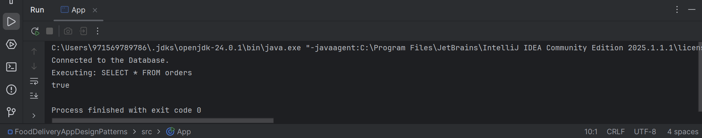

**Benefits:**

* Saves resources (only one connection)
* Centralized DB access control

**Limitations:**

* Can be difficult to unit test due to global state
* Risky in multithreading if not synchronized properly

1. **Factory Pattern – User Role Creation**

**Purpose:** To dynamically create user objects (Admin, Customer, Delivery Agent) based on input.

**Implementation:**

***Java Code***

**Interface: User.java**

public interface User {  
 void displayRole();  
}

**CODE SNIPPET:**

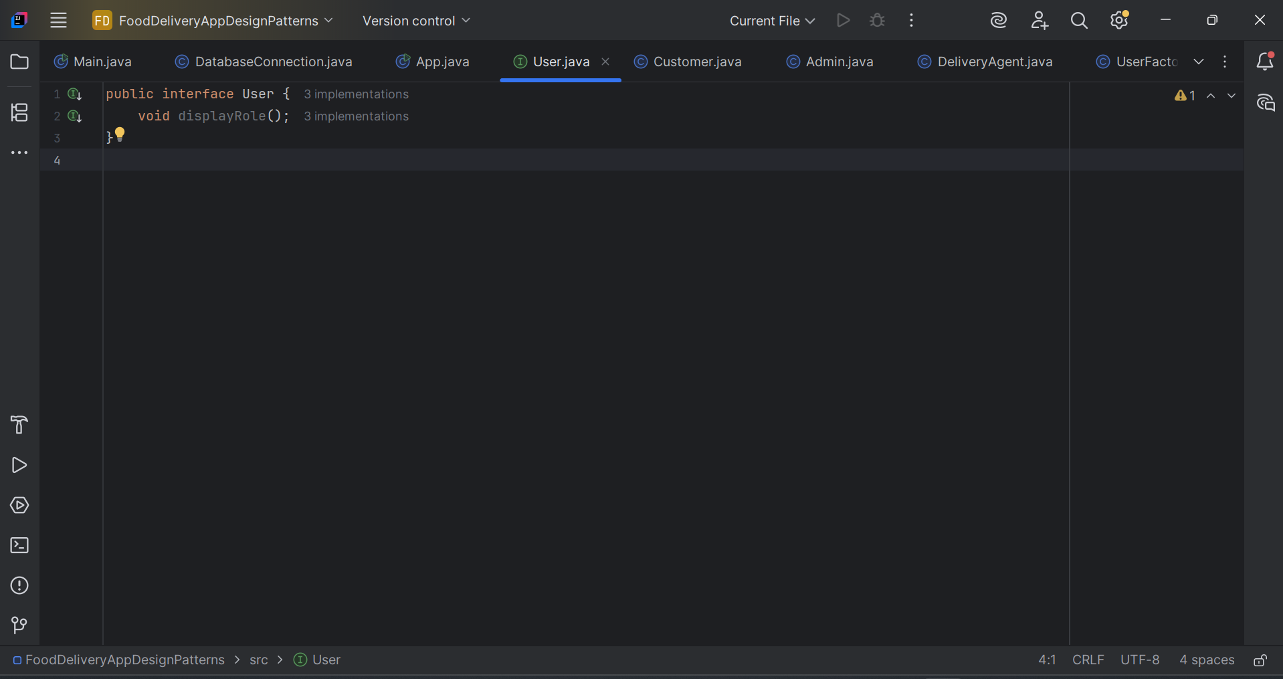

**Class: Customer.java**

public class Customer implements User {  
 public void displayRole() {  
 System.*out*.println("Customer can browse and order food.");  
 }  
}

**CODE SNIPPET**

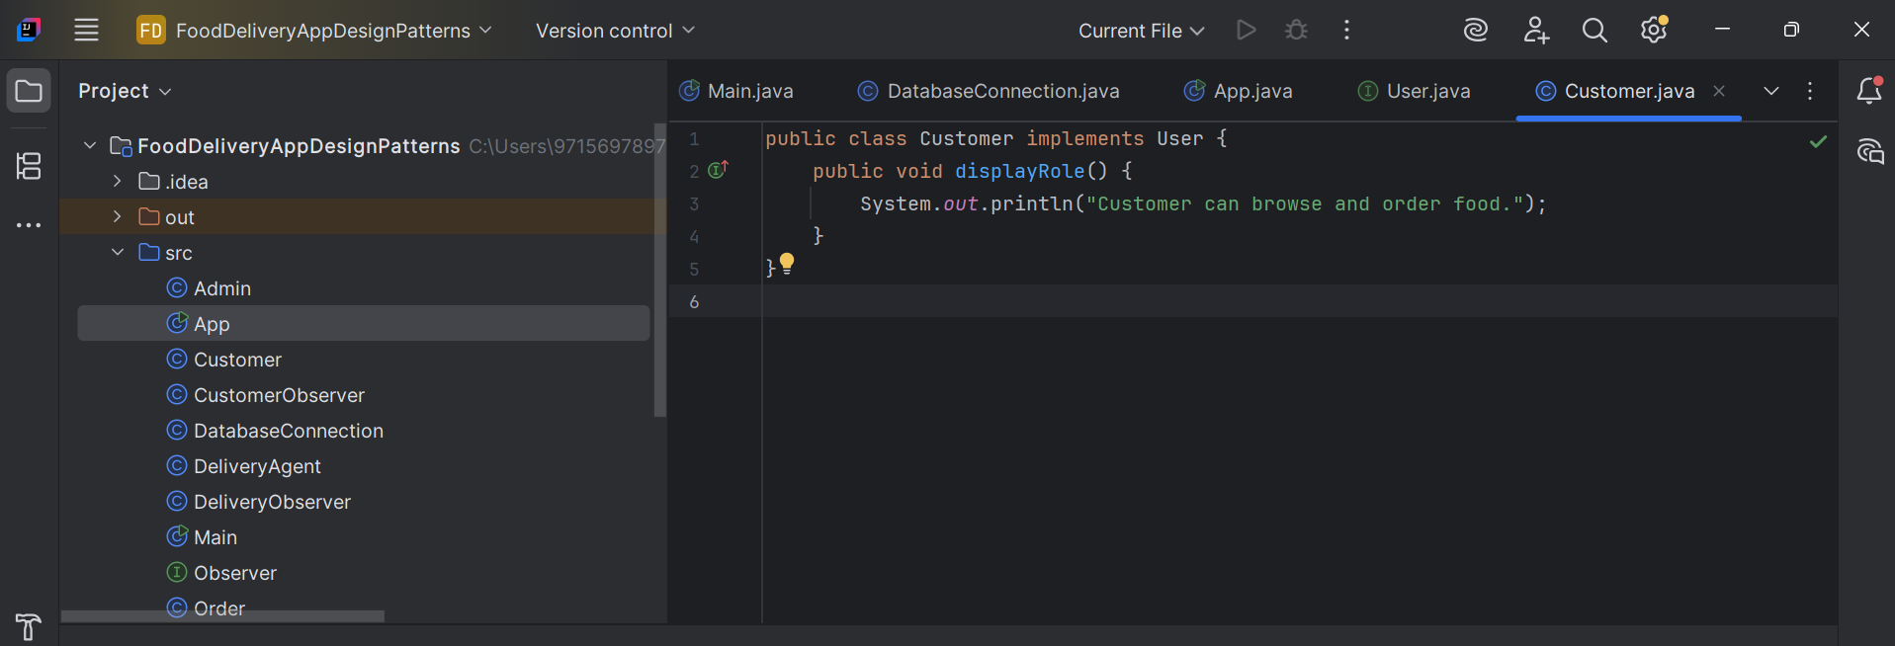

**Class: Admin.java**

public class Admin implements User {  
 public void displayRole() {  
 System.*out*.println("Admin can manage restaurants and users.");  
 }  
}

**CODE SNIPPET**

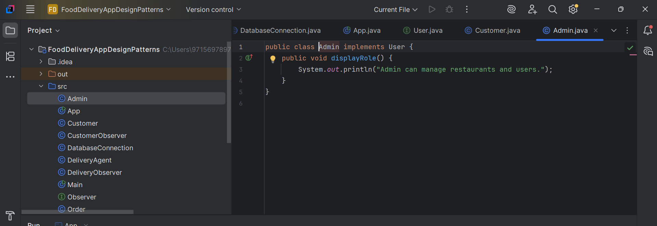

**Class: DeliveryAgent.java**

public class DeliveryAgent implements User {  
 public void displayRole() {  
 System.*out*.println("Delivery Agent can view and deliver orders.");  
 }  
}

**CODE SNIPPET**

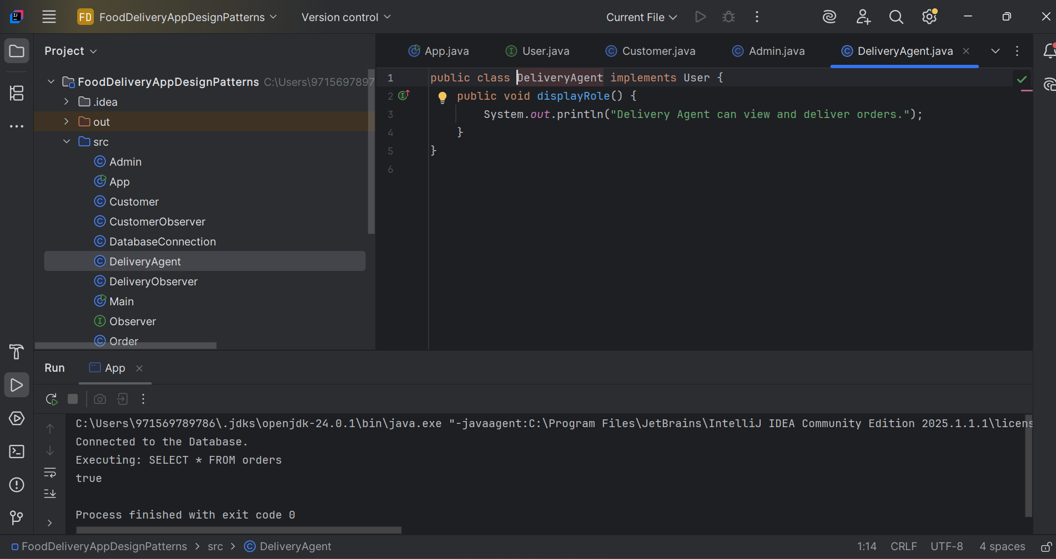

**Class: UserFactory.java**

public class UserFactory {  
 public static User createUser(String type) {  
 switch(type.toLowerCase()) {  
 case "customer": return new Customer();  
 case "admin": return new Admin();  
 case "agent": return new DeliveryAgent();  
 default: throw new IllegalArgumentException("Unknown user type");  
 }  
 }  
}

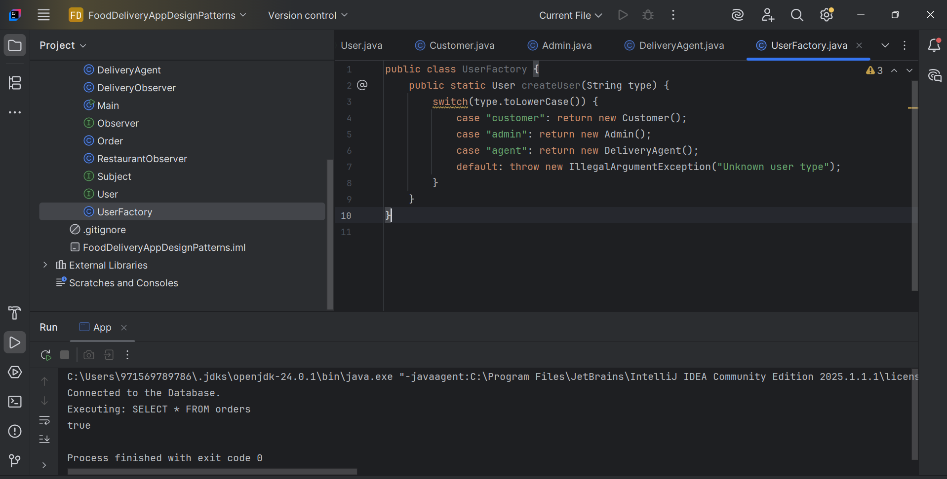

**Usage in: App.java**

public class App {  
 public static void main(String[] args) {  
 DatabaseConnection db1 = DatabaseConnection.*getInstance*();  
 DatabaseConnection db2 = DatabaseConnection.*getInstance*();  
 db1.query("SELECT * FROM orders");  
  
 System.*out*.println(db1 == db2); // should print true  
 }  
}

**CLASS DIAGRAM:**

**USER**

**+displayRole( )**

**CUSTOMER ADMIN DELIVERY AGENT**

**UserFactory**

**+createUser( )**

1. **Observer Pattern – Order Tracking**

**Purpose:** Automatically notify users (Customer, Restaurant, Delivery Agent) when an order’s status changes.

**Implementation**

***Java Code:***

**Interface: Observer.java**

public interface Observer {  
 void update(String status);  
}

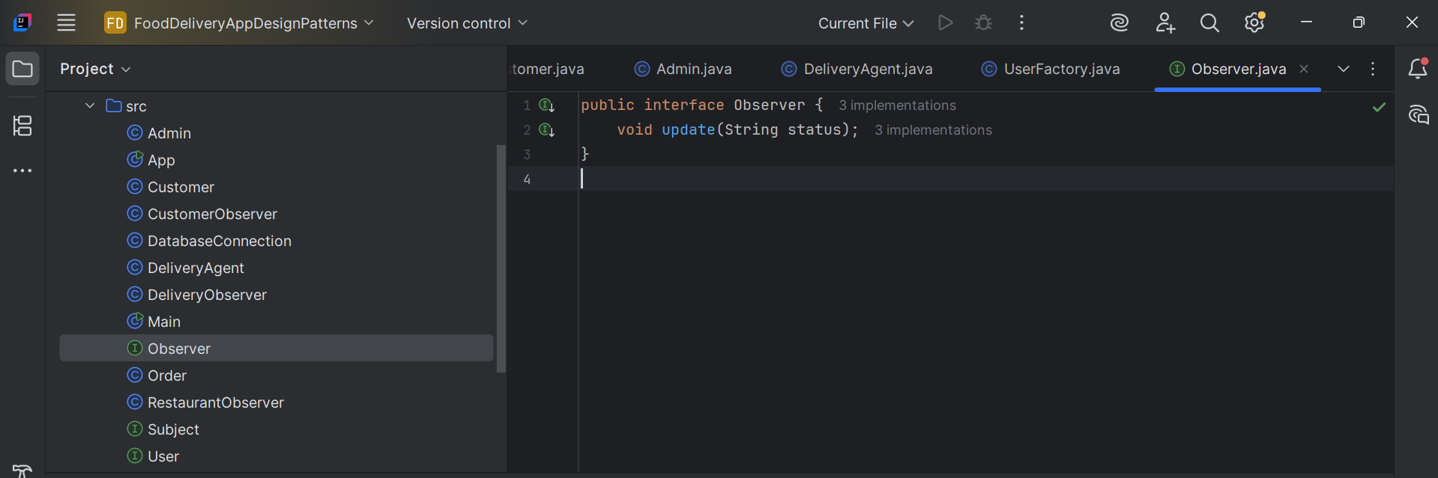

**Interface: Subject.java**

public interface Subject {  
 void addObserver(Observer o);  
 void removeObserver(Observer o);  
 void notifyObservers();  
}

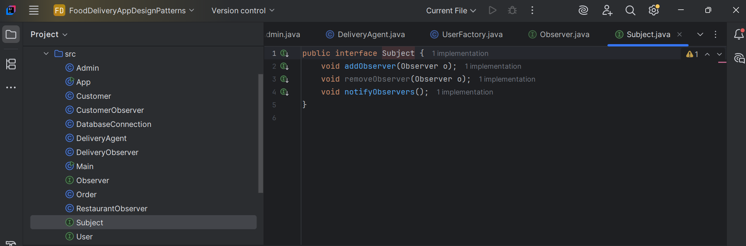

**Class: Order.java**

import java.util.ArrayList;  
import java.util.List;  
  
public class Order implements Subject {  
 private List<Observer> observers = new ArrayList<>();  
 private String status;  
  
 public void setStatus(String status) {  
 this.status = status;  
 notifyObservers();  
 }  
  
 public void addObserver(Observer o) {  
 observers.add(o);  
 }  
  
 public void removeObserver(Observer o) {  
 observers.remove(o);  
 }  
  
 public void notifyObservers() {  
 for (Observer o : observers) {  
 o.update(status);  
 }  
 }  
}

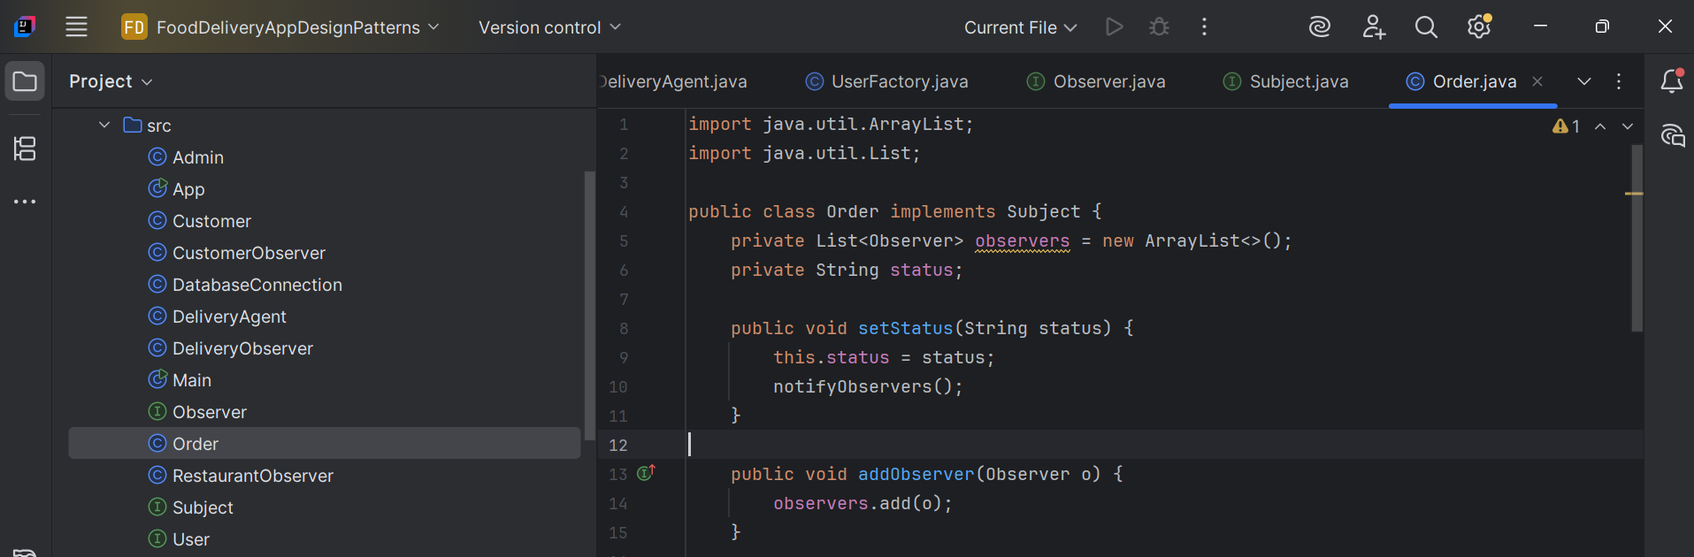

**Observers**

1. **CustomerObserver.java**

public class CustomerObserver implements Observer {  
 public void update(String status) {  
 System.*out*.println("Customer notified: Order is " + status);  
 }  
}

1. **RestaurantObserver.java**

public class RestaurantObserver implements Observer {  
 public void update(String status) {  
 System.*out*.println("Restaurant updated: Order is " + status);  
 }  
}

1. **DeliveryObserver.java**

public class DeliveryObserver implements Observer {  
 public void update(String status) {  
 System.*out*.println("Delivery Agent: Order is " + status);  
 }  
}

**Class: Main.java (Test)**

public class Main {  
 public static void main(String[] args) {  
 Order order = new Order();  
 order.addObserver(new CustomerObserver());  
 order.addObserver(new RestaurantObserver());  
 order.addObserver(new DeliveryObserver());  
  
 order.setStatus("Preparing");  
 order.setStatus("Out for Delivery");  
 order.setStatus("Delivered");  
 }  
}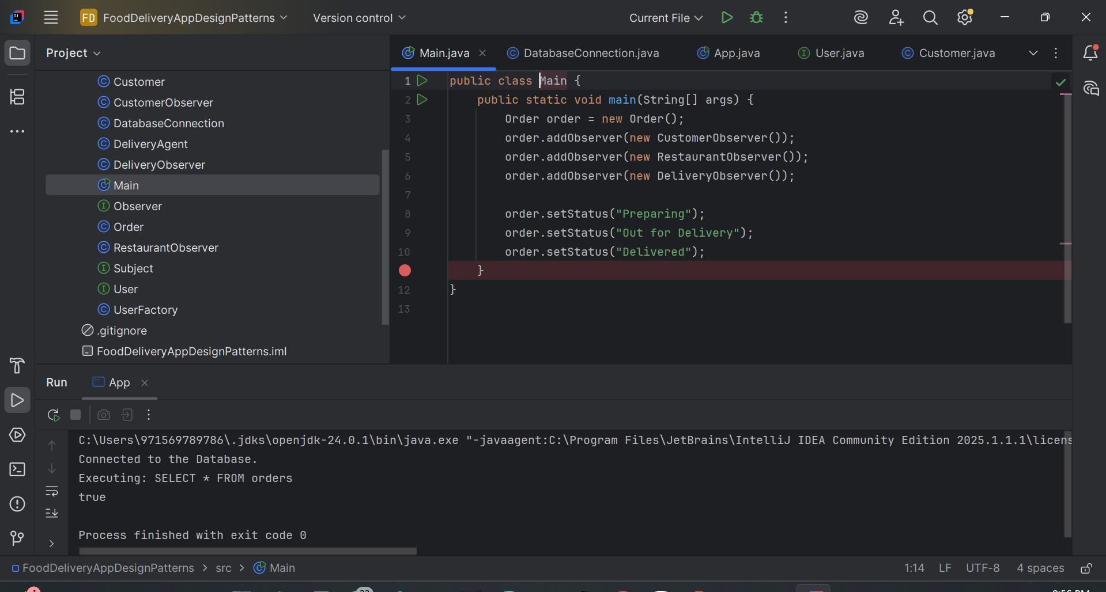

**CLASS DIAGRAM:**

**OBSEVER**

**+update ( )**

CustomerObserver RestaurantObserver DeliveryObserver

**SUBJECT**

**+addObserver()**

**+removeObs()**

**+otifyObs()**

**ORDER**

**Benefits:**

* Real-time updates for all stakeholders.
* Loose coupling between order system and observers.

**Limitations:**

* Can lead to performance issues with many observers.
* Risk of memory leaks if observers aren’t removed properly.

## **OUTPUT SNIPPET**

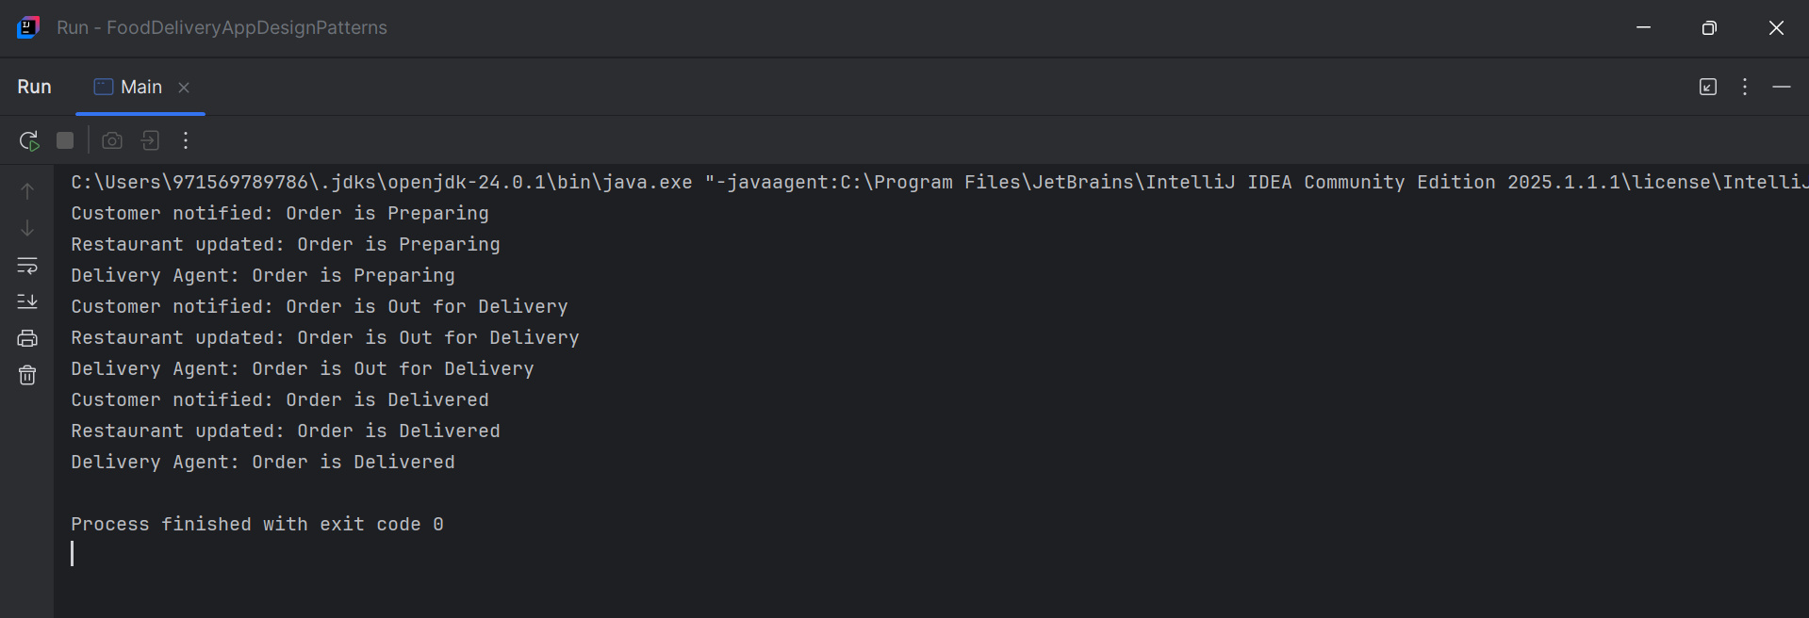

# **CONCLUSION**

This assignment has been a complete reflection of basic and advanced Java programming topics by solving real world problems by being inspired. Beginning with application of the basic object-oriented concepts in a basic banking system the practice assignment showed a successful use of classes and objects it also used encapsulation, as well as constructor overloading. Above, the presence of finalize() also simulated reality, where objects aren’t always going after the end of a method call.

The second task dealt with inheritance and polymorphism, with a focus on an Employee Management System. Abstract classes and interfaces were used to force design contracts, and method overriding and casting demonstrated Java’s runtime polymorphism integrations. This assignment demonstrated the flexibility of object-oriented features of Java to create scalable software systems.

The third task combined string manipulation with exception handling to simulate a Student Grading System. Exception handling and the solemn try-catch-finally blocks poured out my heart to show how Java could handle user input validation and the sorts of runtime errors and handling in the sweetest of ways that real life code would need.

Task 4 Why did we implement a Library Management System – you did – in Java Collections? It demonstrated the remarkable ability of the Java Collection Framework to organize and manage dynamic datasets effectively. Generics and wildcards enabled type safety as well as the reuse of code components.

Lastly, the design patterns case study illustrated real world usage of Singleton, Factory and Observer patterns in an Online Food Delivery App. It exemplified how these patterns lead to sustainability, scalability, and modular structure in industrial-strength Java applications. Class diagrams with code snippets enhanced understanding of structural and behavioral responsibilities of each pattern.

Overall, this assignment has improved not only the knowledge of basic Java related knowledge but also the problem-solving capability, the way to think the software design, and critical application of best practices. The knowledge gained from these exercises provides a strong foundation for future academic and professional development in software engineering and application development.

# **REFERENCES**

1. TutorialsPoint. (n.d.). Java Collections Framework *https://www.tutorialspoint.com/java/java_collections.htm*
2. GeeksforGeeks. (n.d.). Design Patterns in Java

*https://www.geeksforgeeks.org/software-design-patterns/*

1. Oracle (n.d.). The Java Tutorials. Oracle

*https://docs.oracle.com/javase/tutorial/*

# **DECLARATION OF ORIGINALITY**

I hereby declare that this assignment is my original work, and I have referenced all sources as required. I understand that failure to adhere to academic integrity will result in disciplinary action.

Student Name: Merry Subedi

Student ID: LC00017003482

Signature:



Date: 20th July, 2025